**REPORT**

**(Mobile Mart System)**

**1.INTRODUCTION**

**1.1.Background**

In the fast-changing world, information technology and information management are going to play an important role. We are living in the computer age during past some year. The computer has gaining popularity. Computer revolution found its way into almost every aspect of human life and living. A computer is admirably suited to handle any information and hence is an information processor that is, it can receive data, perform some basic operations on that data and produce results according to a predetermined program.

This software is used mainly for Mobile stores to maintain the details of mobile store such as stock and account.

**1.2.Objective**

The mobile mart system software is so designed as to ease the workload of mobile shop professionals. The main feature includes Inventory, and stock control and client management. Today’s world is computer world because most of work is doing with the help of computer. Dependency on computer is behind the few reasons. We cannot easily manage to store large number of data or information single handle. If we will be need some information or data in urgency then we cannot manage in manually these works are very difficult if we cannot use computer.

As the generic software it can be used by a wide variety of outlets (Retailer and Wholesalers) to automate the process of manually maintaining records related to the subject of maintain the Stock and Cash flow. This software is basically updating the manual mobile mart system to automated Inventory system. So that organization can manage their record in efficient way and organize them.

* The main objective is to automate non-computer environment.
* To save manpower.
* It will speed the processing of data and transaction.
* It will provide best security features such as provision of passwords.

**2.Purpose and Future Scope**

**1.3.1.Purpose**

The purpose of this document is to specify requirements and to give guidelines for the development of above said project. In particular it gives guidelines on how to prepare the above said project.

This document is intended to be a practical guide for people who developing this software.

**1.3.2. Scope**

The proposed system helps them in many ways. It helps them do billing very easily. Account maintenance also becomes easier. They can keep track of their contacts, feeding details, messages and records. The software is provided with all the master entries to enter any new contact, or data, to add or modify and delete.

As this is generic software it can be used by a wide variety of outlets (Retailers and Wholesalers) to automate the process of manually maintaining the records related to the subject of maintaining the stock and cash flow.

In future it can be modify, so that it can be done online. In order to meet these facility this is the major change which can be done in future regarding this project.

**3.SURVEY OF TECHNOLOGIES**

**2.1.JAVA**

Java is a popular general-purpose programming language and computing platform. It is fast, reliable, and secure. According to Oracle, the company that owns Java, Java runs on 3 billion devices worldwide.

Considering the number of Java developers, devices running Java, and companies adapting it, it's safe to say that Java will be around for many years to come.

This guide will provide everything you need to know about Java programming language before you learn it. More specifically, you will learn about features of Java programming, its applications, reasons to learn it, and how you can learn it the right way.

**2.2.MySQL**

MySQL is a fast, easy-to-use RDBMS being used for many small and big businesses. MySQL is developed, marketed and supported by MySQL AB, which is a Swedish company. MySQL is becoming so popular because of many good reasons –

* MySQL is released under an open-source license. So you have nothing to pay to use it.
* MySQL is a very powerful program in its own right. It handles a large subset of the functionality of the most expensive and powerful database packages.
* MySQL uses a standard form of the well-known SQL data language.
* MySQL works on many operating systems and with many languages including PHP, PERL, C, C++, JAVA, etc.
* MySQL works very quickly and works well even with large data sets.
* MySQL is very friendly to PHP, the most appreciated language for web development.
* MySQL supports large databases, up to 50 million rows or more in a table. The default file size limit for a table is 4GB, but you can increase this (if your operating system can handle it) to a theoretical limit of 8 million terabytes (TB).

**4.REQUIREMENTS AND ANALYSIS**

**3.1.Problem Definition**

Problem introduction or problem starting is the starting point of the software development activity. The objective of this statement is to answer: Exactly *what must the system do*? The software project is initiated by the client’s need. In the beginning, these needs are on the minds of various people in the client’s organization. The analyst has to identify the requirements by talking to the people and understanding to their needs. It goes without saying that an accurate and through understanding of software requirement are essentials to the success of software development effort. All further development like system analysis. System design and coding will depends on how accurate and well understood the requirements are poorly analyzed and specified software will disappoint the user and will bring brief to the developer. No matter how well designed and well appearances are often deceiving. Chances of misinterpretation are very high, ambiguity is probable and communication gap between customer and developer is bound to bring confusions. Requirements understanding begin with a clear and concise heading stating in sentence the task to be performed. Then requirements are describe in a technical manner precise statement.

**Feasibility Study**

All projects are feasible given unlimited resources and infinite time! Unfortunately, the development of computer based system is more likely to be plagued by a scarcity of resources and difficult delivery dates. It is both necessary and prudent to evaluate the feasibility of the project at the earliest possible time. Months or years of effort, Money loss and untold professional embarrassment can be averted I better understand the project at its study time. This type of study determines if an application can and should be developed. Once it has been determining that, application is feasible. After that analyst can go ahead and prepares the project specification, which finalizes project requirements. Feasibility studies are undertaken within tight time constraints.

1. **Technical Feasibility**
2. **Operational Feasibility**
3. **Economic Feasibility**
4. **Legal Feasibility**

**1.Technical Feasibility**

As we know the technical feasibility is concerned with specifying equipment and software that will successfully satisfy the user requirement. The technical needs of the system may vary considerably, but might include:

* The facility to produce outputs of advertisements, shopping and mailing in a given time for ease of use.
* Response time under certain condition is minimal.
* Ability to process a certain volume of transaction at a particular speed.
* Facility to communicate data to distinct location.

In examining the technical feasibility, configuration of the system is given more importance than the actual make of hardware. The configuration should give the complete picture about the system’s requirements- how many workstations are required, how these units are interconnected so that they could operate and communicate smoothly.

**2.Operational Feasibility**

Proposed projects are beneficial only if they can be turned into information system that will meet the financial management requirements of the business/organization. This test of feasibility asks if the system will work when it developed and installed. Are there major barriers to implementation?

Some of the important questions that are useful to test the operational feasibility of a project are given below:

* + Is there sufficient support for the project from the implementation? From user? If the present system is well liked and used to the extent that persons will not be able to see reasons for change, there may be resistance.
  + Are current business methods acceptable to the user? If they are not, user may welcome a change that will bring about a more operational and useful system.
  + Have the user been involved in the planning and development of the Project? If they are involved at the earliest stage of project development, the chances of resistance can be possibly reduced.
  + Will the proposed system cause harm? Will it produce poorer result in any case or area?
  + Will the performance of staff member fall down after implementation? Issue that
  + Appears to be quite minor at the early stage can grow into major problem after Implementation.

**3.Economical Feasibility**

Economic analysis is the most frequently used technique for evaluating the effectiveness of the proposed system. More commonly known as cost/benefits analysis, the procedure is to determine the benefits and savings that are expected from the purposed system and compared with costs.

If benefits outweigh cost, a decision is taken to design and implement the system. Otherwise, further justification or alternative of the proposed system will have to be made if it has a chance of being approved. This is an ongoing effort that improves in accuracy at each phase of the system life cycle. The analysis part also clears the doubt of economic problems which could be possible in developing the system. As already mentioned that the company has to just pay the developed software cost and not other investment is needed at the time of implementation of the new system as the preliminary requirements already exist in the company.

**4.Legal Feasibility**

In the legal feasibility is necessary to check that the software we are going to develop is legally correct which means that the ideas which we have taken for the proposed system will be legally implemented or not so, it is also an important step in feasibility study.

**3.2.Planning and Scheduling**

A project plan needs to be created to ensure the timely completion of the project. As part of project analysis, we break the project down to a number of stages and use a Gantt chart and PERT chart to describe specific tasks and status.

The Work Breakdown Structure of our proposed system “E-Commerce” is shown below:

|  |  |  |  |  |  |
| --- | --- | --- | --- | --- | --- |
| **ID** | **Task Name** | **Duration** | **Start** | **Finish** | **Predecessors** |
| 1 | Project Initiation | 2 days |  |  |  |
| 2 | Draft Project Plan | 5 days |  |  |  |
| 3 | Analysis Phase | 8 days |  |  |  |
| 4 | Plan User Interviews | 2 days |  |  |  |
| 5 | Schedule users Interviews | 4 days |  |  |  |
| 6 | Conducting users Interviews | 3 days |  |  |  |
| 7 | System Design | 15 days |  |  | 6 |
| 8 | Modules Design | 10 days |  |  |  |
| 9 | Data Structure Design | 5 days |  |  | 8 |
| 10 | User Interface Design | 4 days |  |  |  |
| 11 | Coding Phase | 36 days |  |  |  |
| 12 | Testing Phase | 10 days |  |  |  |
| 13 | Integration Testing | 5 days |  |  |  |
| 14 | System Level Testing | 6 days |  |  |  |
| 15 | Implementation | 3 days |  |  |  |
| 16 | Post-Implementation Review | 4 days |  |  |  |

**3.3.Requirements Specification**

**3.3.1.Softwar**

* Java/JDK
* NetBeans
* MySQL
* SQL YOG

**3.3.2.Hardware**

* Pentium IV Processor
* 512 MB RAM
* 40 GB HDD
* Color Monitor
* Keyboard, Mouse

**3.4.Preliminary Product Description**

* **Login:** This module has a drop-down list box from where we have to select

**ADMIN or USER**. The **ADMIN** has all the rights in the software including updating the status of his site. The other fields in login **are** username and password. If the username and password are correct then it is directed to next page.

* **New user:** This module is for the users who do not have their account. Here user is allowed to create an account to login. The account creation is done by filling the registration form with user details such as name, phone, email etc.
* **Product:** This module has information regarding the mobiles such as its name, model, color, price information, its features etc. The **ADMIN** has the authority to Add, Delete, Update etc. The **USER** can only view the Mobile, add to cart only those in the stock etc.
* **Accessories:** This module consists of various available accessories of the Mobile with its name and picture, price information etc.
* **Search:** This module helps the customer to ease his search based on his budget or interest. The search can be done on different categories like mobile model name, model number, color, price etc.
* **Cart:** User can select any number of Mobile and add to the cart. He can also remove from the cart if he dislikes it later.
* **Payment:** This module describes the payment done by the customer. The payment information can include information like the model purchased, quantity, mode of payment (cash, loan) etc.
* **Stocks:** This gives the details regarding the products available for sale.

**5.Conceptual Models**

**SYSTEM ARCHITECTURE DESIGN**

**1.Defining a System**

Collection of component, which are interconnected, and work together to realize some objective, from a system. There are three components in every system, namely input, processing and output

Input Output

Processing

**SYSTEM DEVELOPMENT LIFE CYCLE**

The **System development life cycle (SDLC)**, or **Software development processing** [systems engineering](http://en.wikipedia.org/wiki/Systems_engineering), [information systems](http://en.wikipedia.org/wiki/Information_systems) and [software engineering](http://en.wikipedia.org/wiki/Software_engineering), is a process of creating or altering information systems, and the models and [methodologies](http://en.wikipedia.org/wiki/Methodologies) that people use to develop these systems. In software engineering, the SDLC concept underpins many kinds of [software development methodologies](http://en.wikipedia.org/wiki/Software_development_methodologies). These methodologies form the framework for planning and controlling the creation of an information system the [software development process](http://en.wikipedia.org/wiki/Software_development_process).

Broadly, following are the different activities to be considered while defining the system development life cycle for the said project:

* Problem Definition
* System Analysis
* Study of existing system
* Drawback of the existing system
* Proposed system
* System Requirement study
* Data flow analysis
* Feasibility study
* System design
* Input Design (Database & Forms)
* Updating
* Query /Report design
* Administration
* Testing
* Implementation
* Maintenance

**1.2.System Analysis**

**Systems analysis** is the study of sets of [interacting](http://en.wikipedia.org/wiki/Interaction) [entities](http://en.wikipedia.org/wiki/Entity), including computer systems analysis. This field is closely related to [requirement analysis](http://en.wikipedia.org/wiki/Requirement_analysis) or [operations research](http://en.wikipedia.org/wiki/Operations_research). It is also "an explicit formal inquiry carried out to help someone (referred to as the decision maker) identify a better course of action and make a better decision than he might otherwise have made. System development can generally be thought of having two major components: systems analysis and systems design. In System Analysis more emphasis is given to understanding the details of an existing system or a proposed one and then deciding whether the proposed system is desirable or not and whether the existing system needs improvements. Thus, system analysis is the process of investigating a system, identifying problems, and using the information to recommend improvement to the system.

**1.3.System Design**

Systems design is the process of defining the architecture, components, modules, interfaces, and [data](http://en.wikipedia.org/wiki/Data) for a [system](http://en.wikipedia.org/wiki/System) to satisfy specified [requirements](http://en.wikipedia.org/wiki/Requirement). One could see it as the application of [systems theory](http://en.wikipedia.org/wiki/Systems_theory) to [product development](http://en.wikipedia.org/wiki/Product_development). There is some overlap with the disciplines of [systems analysis](http://en.wikipedia.org/wiki/Systems_analysis), [systems architecture](http://en.wikipedia.org/wiki/Systems_architecture) and [systems engineering](http://en.wikipedia.org/wiki/Systems_engineering). If the broader topic of [product development](http://en.wikipedia.org/wiki/Product_development) "blends the perspective of marketing, design, and manufacturing into a single approach to product development," then design is the act of taking the marketing information and creating the design of the product to be manufactured. Systems design is therefore the process of defining and developing [systems](http://en.wikipedia.org/wiki/System) to satisfy specified [requirements](http://en.wikipedia.org/wiki/Requirement) of the user. Until the 1990s systems design had a crucial and respected role in the [data processing](http://en.wikipedia.org/wiki/Data_processing) industry. In the 1990s [standardization](http://en.wikipedia.org/wiki/Standardization) of hardware and software resulted in the ability to build [modular](http://en.wikipedia.org/wiki/Modularity_(programming)) systems. The increasing importance of software running on generic platforms has enhanced the discipline of [software engineering](http://en.wikipedia.org/wiki/Software_engineering). [Object-oriented analysis and design](http://en.wikipedia.org/wiki/Object-oriented_analysis_and_design) methods are becoming the most widely used methods for computer systems design. The [UML](http://en.wikipedia.org/wiki/Unified_Modeling_Language) has become the standard language in object-oriented analysis and design. It is widely used for modeling software systems and is increasingly used for high designing non-software systems and organizations.

**ENTITY RELATION DIAGRAMS**

The Entity Relation Model or Entity Relation Diagram (ERD) is a data model or diagram for high-level description of conceptual data model, and it provides a graphical notation for representing such data models in the form of entity relationship diagrams. Such models are typically used in the first stage of Management information system design, they are used for example, to describe information needs and/ or the type of information that is to be stored in the Database during the requirement analysis.

In the case of design a Management Information System that is based on a database, the conceptual data model is, a later stage (usually called logical design), mapped to a logical data model such as, relational data model; this is turn in mapped to a physical model during physical design. Note that sometimes, both of the phases are referred a “physical design”. There are number of convention for entity-relation diagrams (ERDs). The classical notation is describe in the remainder of this article, and mainly related to the conceptual modeling. There is a range of notation more typically employed in physical and logical database design.

Request

Mobile Detail

Employee

Place Order

Check Login ID

Order Detail

Login

Request new member

Registration

**DATA FLOW DIAGRAM**

The data flow diagram shows the flow of data within any system. It is an important tool for designing phase of software engineering. Larry Constantine first developed it. It represents graphical view of flow of data. It’s also known as BUBBLE CHART. The purpose of DFD is major transformation that will become in system design symbols used in DFD.

In the DFD, four symbols are used and they are as follows.

1. A square defines a source (originator) or destination of system data.
2. An arrow identifies data flow-data in motion. It is 2a pipeline through which information flows.
3. A circle or a “bubble “(Some people use an oval bubble) represents a process that transfers informing data flows into outgoing data flows.
4. An open rectangle is a data store-data at rest, or a temporary

Repository of data.

**Context Level Data Flow Diagram**

This level shows the overall context of the system and its operating environment and shows the whole system as just one process. Online book store is shown as one process in the context diagram; which is also known as zero level DFD, shown below. The context diagram plays important role in understanding the system and determining the boundaries. The main process can be broken into sub-processes and system can be studied with more detail; this is where 1st level DFD comes into play.

**Zero Level DFD**

PRODUCT

COUSTOMER

Request

ADMIN

Request fulfil

Zero Level Data Flow Diagram

**First Level DFD**

This level (level 1) shows all processes at the first level of numbering, data stores, external entities and the data flows between them. The purpose of this level is to show the major high-level processes of the system and their interrelation. A process model will have one, and only one, level-1 diagram. A level-1 diagram must be balanced with its parent context level diagram, i.e. there must be the same external entities and the same data flows, these can be broken down to more detail in the level 1.

Enter the software



Display errors

Admin

Employee

Buy product

View product

Customer Details

Details

Products

**Data Tables:-**

**Bill**

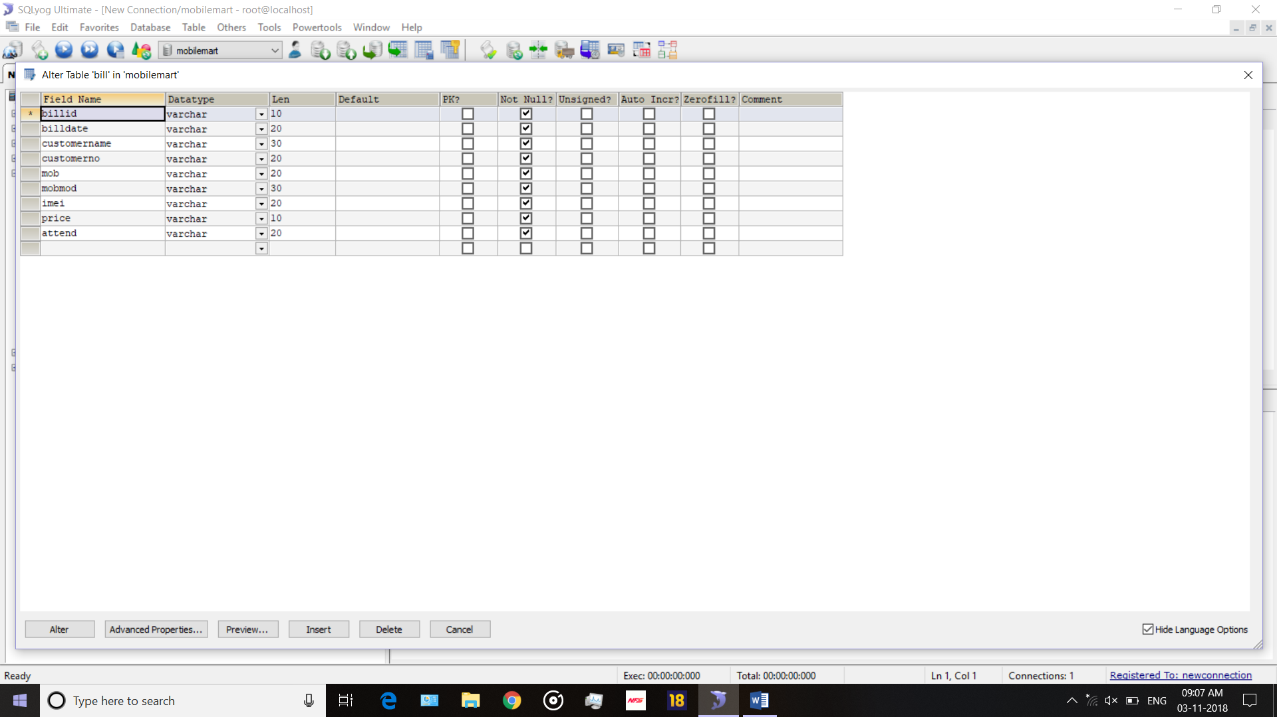

**Employee**

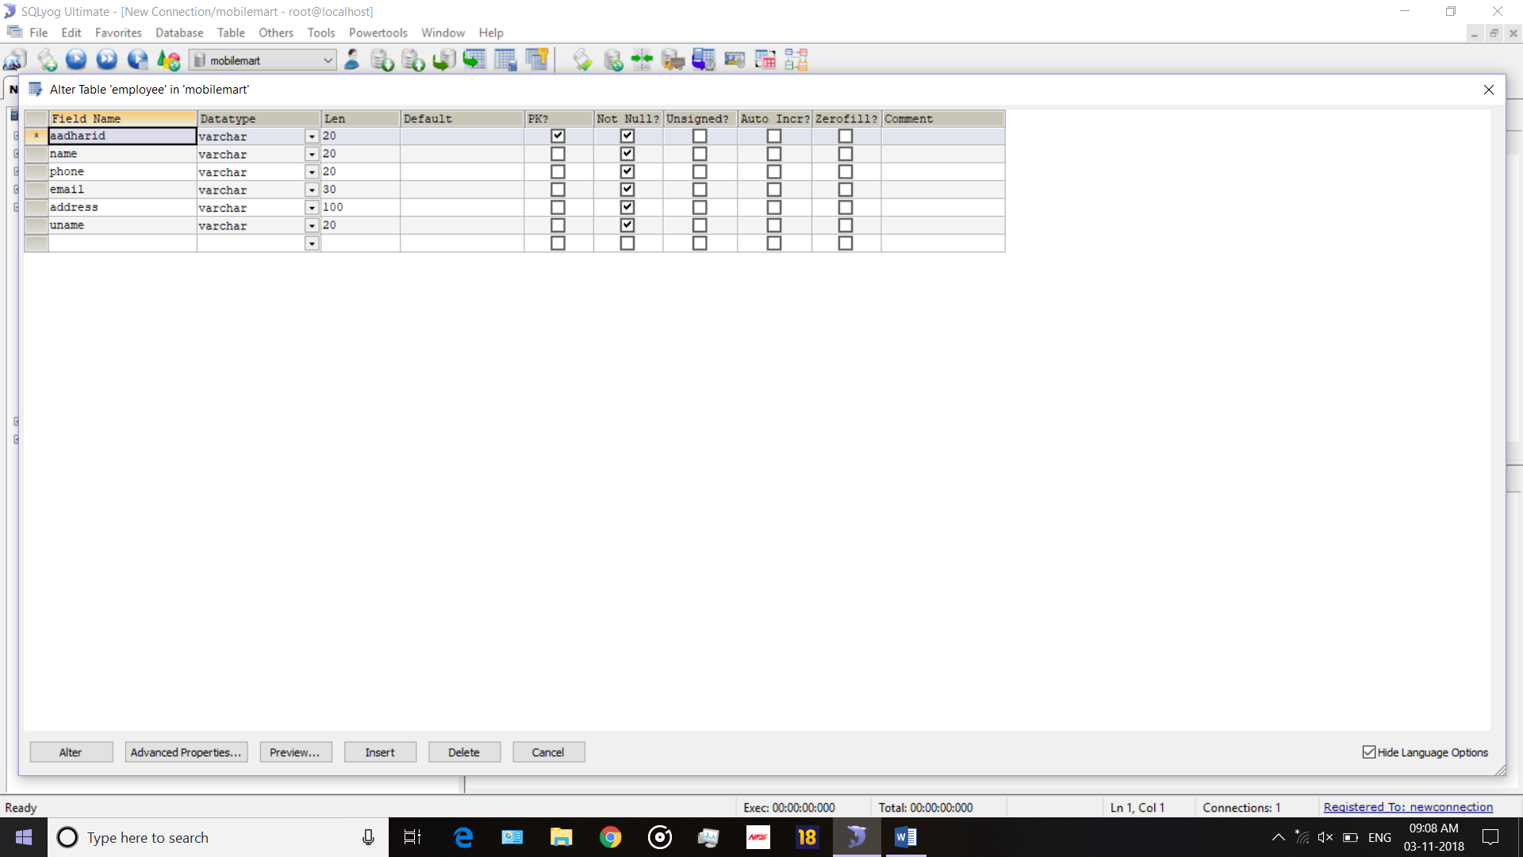

**Login**

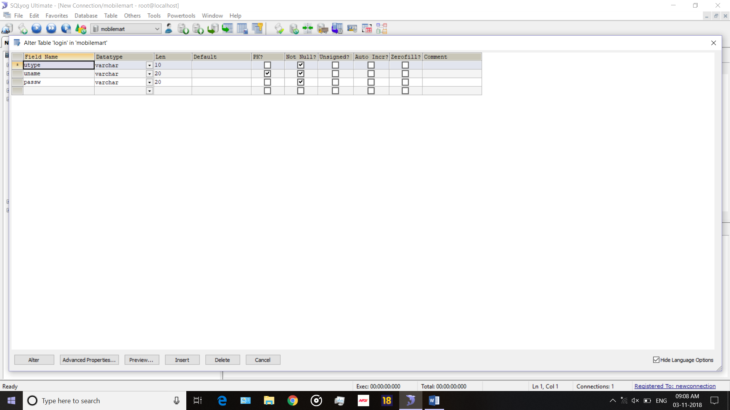

**Mobile company**

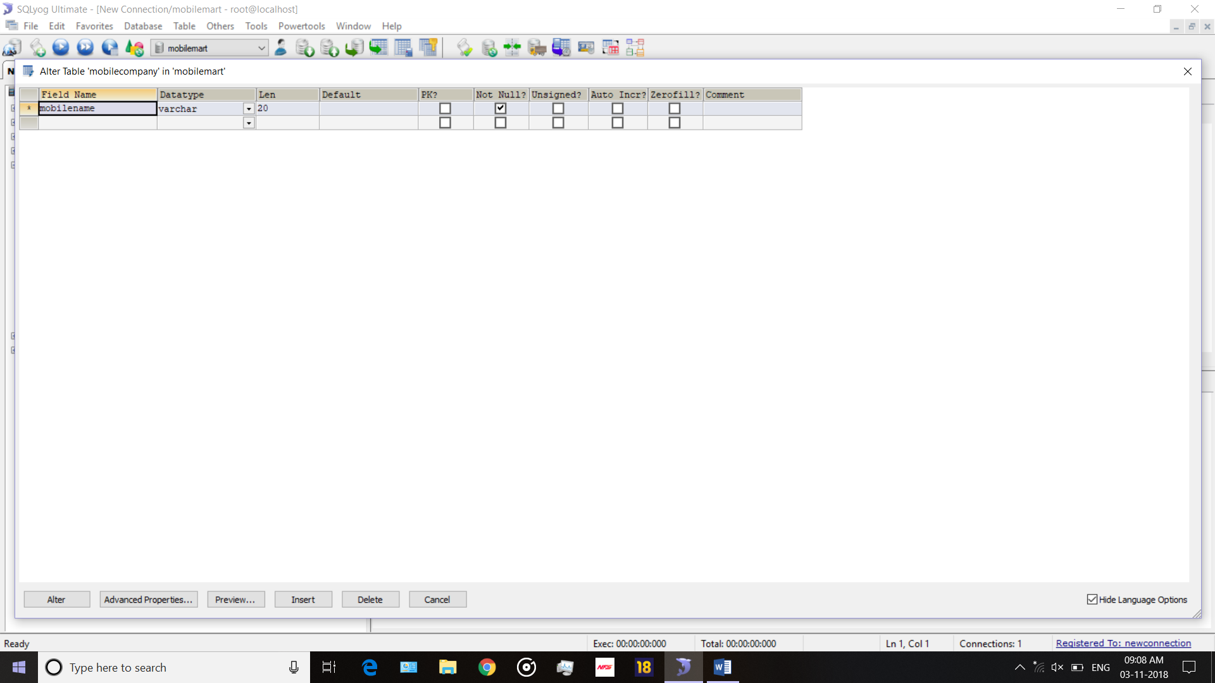

**Mobile Details**

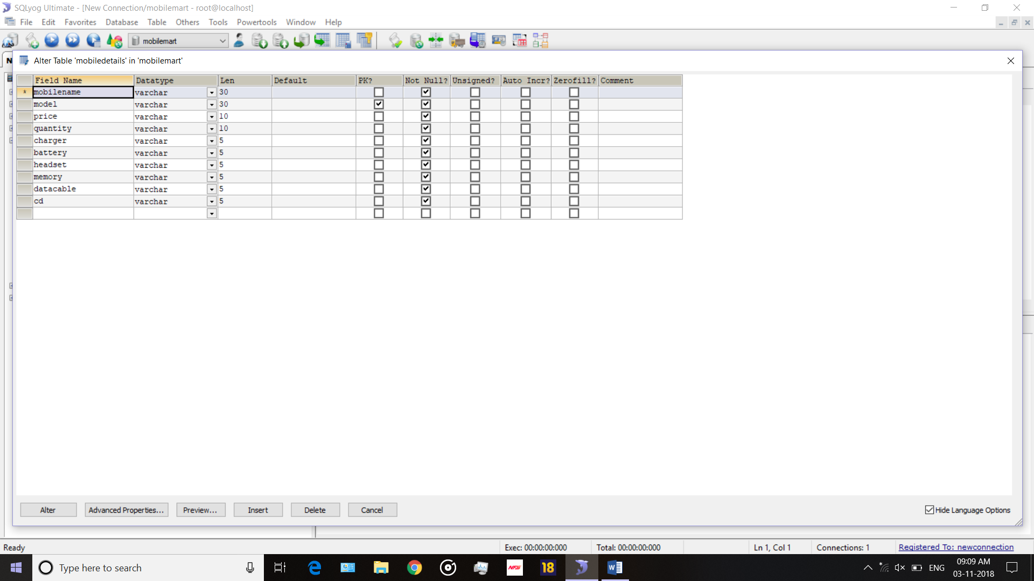

**LOGIN**

|  |  |  |  |
| --- | --- | --- | --- |
| **Name Column** | **Data Type** | **Constraints** | **Size** |
| User Name | Varchar | Primary Key | 20 |
| User type | Varchar | Not Null | 10 |
| Password | Varchar | Not Null | 20 |

**Mobile Company**

|  |  |  |  |
| --- | --- | --- | --- |
| **Name Column** | **Data Type** | **Constraints** | **Size** |
| Model name | Varchar | Not Null | 20 |

**Mobile Details**

|  |  |  |  |
| --- | --- | --- | --- |
| **Name Column** | **Data Type** | **Constraints** | **Size** |
| Mobile Name | Varchar | Not Null | 30 |
| Model | Varchar | Primary Key | 20 |
| Price | Numeric | Not Null | 7,2 |
| Quantity | Varchar | Not Null | 10 |
| Charger | Varchar | Not Null | 5 |
| Battery | Varchar | Not Null | 5 |
| Headset | Varchar | Not Null | 5 |
| Memory | Varchar | Not Null | 5 |
| Data cable | Varchar | Not Null | 5 |
| Cd | Varchar | Not Null | 5 |

**BILL**

|  |  |  |  |
| --- | --- | --- | --- |
| **Name Column** | **Data Type** | **Constraints** | **Size** |
| Bill id | Number | Not Null | 10 |
| Customer name | Varchar | Not Null | 20 |
| Mobile | Varchar | Not Null | 20 |
| Price | Numeric | Not Null | 7,2 |
| Customer number | Varchar | Not Null | 20 |
| Bill date | Date | Not Null | 20 |
| Mobile Module | Varchar | Not Null | 20 |
| imei | Varchar | Not Null | 10 |

**Employee**

|  |  |  |  |
| --- | --- | --- | --- |
| **Name Column** | **Data Type** | **Constraints** | **Size** |
| Aadhar id | Varchar | Primary Key | 30 |
| Name | Varchar | Not Null | 20 |
| Phone | Numeric | Not Null | 7,2 |
| E-mail | Varchar | Not Null | 20 |
| Address | Varchar | Not Null | 100 |
| User Name | Varchar | Not Null | 20 |

Coding

**Code for DB Connection**

package DB;

import java.sql.Connection;

import java.sql.DriverManager;

import java.sql.PreparedStatement;

import java.sql.ResultSet;

import java.sql.Statement;

public class DBConnection {

public Connection con;

public PreparedStatement pstmt;

public ResultSet rst;

public Statement stmt;

public DBConnection()

{

try{

Class.forName("com.mysql.jdbc.Driver");

con=DriverManager.getConnection("jdbc:mysql://localhost/mobilemart","root","");

}

catch(Exception e)

{

e.printStackTrace();

}

}

}

**Code for Add Mobile module**

private void jMenuItem5ActionPerformed(java.awt.event.ActionEvent evt) {

addmob.setVisible(true);

try {

DBConnection db=new DBConnection();

jComboBox1.removeAllItems();

db.pstmt=db.con.prepareStatement("select mobilename from mobilecompany");

db.rst=db.pstmt.executeQuery();

jComboBox1.addItem("Select-----");

while(db.rst.next())

{

jComboBox1.addItem(db.rst.getString(1));

}

} catch (Exception e) {

e.printStackTrace();

}

}

**Code for Save Details**

**Code for mouse clicked**

private void jLabel7MouseClicked(java.awt.event.MouseEvent evt) {

String mob=jComboBox1.getSelectedItem().toString();

String mod=jTextField1.getText();

String price=jTextField2.getText();

String quan=jTextField5.getText();

String ch="",bt="",hd="",mm="",dc="",cd="";

if(jCheckBox2.isSelected())

{

ch="Yes";

}

else

{

ch="No";

}

if(jCheckBox3.isSelected())

{

bt="Yes";

}

else

{

bt="No";

}

if(jCheckBox4.isSelected())

{

hd="Yes";

}

else

{

hd="No";

}

if(jCheckBox6.isSelected())

{

mm="Yes";

}

else

{

mm="No";

}

if(jCheckBox1.isSelected())

{

dc="Yes";

}

else

{

dc="No";

}

if(jCheckBox5.isSelected())

{

cd="Yes";

}

else

{

cd="No";

}

if(mob.equals("Select-----"))

{

JOptionPane.showMessageDialog(this,"Please select Mobile Name");

}

else

{

try {

DBConnection db=new DBConnection();

db.pstmt=db.con.prepareStatement("insert into mobiledetails values('"+mob+"','"+mod+"','"+price+"','"+quan+"','"+ch+"','"+bt+"','"+hd+"','"+mm+"','"+dc+"','"+cd+"')");

int i=db.pstmt.executeUpdate();

if(i>0)

{

JOptionPane.showMessageDialog(this,"Data Insertion Successfully");

jTextField1.setText("");

jTextField2.setText("");

jTextField5.setText("");

jCheckBox2.setSelected(true);

jCheckBox3.setSelected(false);

jCheckBox4.setSelected(true);

jCheckBox6.setSelected(false);

jCheckBox1.setSelected(false);

jCheckBox5.setSelected(false);

jComboBox1.grabFocus();

}

} catch (Exception e) {

e.printStackTrace();

}

}

}

**Code for mouse entered**

private void jLabel7MouseEntered(java.awt.event.MouseEvent evt) {

jLabel7.setOpaque(true);

jLabel7.setBackground(Color.black);

}

**Code for mouse exited**

private void jLabel7MouseExited(java.awt.event.MouseEvent evt) {

jLabel7.setBackground(Color.white);

jLabel7.setOpaque(true);

}

**Code for Cancel**

**Code for mouse clicked**

private void jLabel6MouseClicked(java.awt.event.MouseEvent evt) {

jTextField1.setText("");

jTextField2.setText("");

jTextField5.setText("");

jCheckBox2.setSelected(true);

jCheckBox3.setSelected(false);

jCheckBox4.setSelected(true);

jCheckBox6.setSelected(false);

jCheckBox1.setSelected(false);

jCheckBox5.setSelected(false);

addmob.setVisible(false);

}

**Code for mouse entered**

private void jLabel6MouseEntered(java.awt.event.MouseEvent evt) {

jLabel6.setOpaque(true);

jLabel6.setBackground(Color.black);

}

**Code for mouse exited**

private void jLabel6MouseExited(java.awt.event.MouseEvent evt) {

jLabel6.setBackground(Color.white);

jLabel6.setOpaque(true);

}

**Code for Search Mobile module**

private void jMenuItem6ActionPerformed(java.awt.event.ActionEvent evt) {

searchmob.setVisible(true);

jLabel12.setText("Search Mobile");

jLabel22.setVisible(false);

searchmob.setTitle("Search Mobile");

jTextField6.setVisible(false);

jTextField7.setVisible(false);

jTextField8.setVisible(false);

jTextField4.setVisible(false);

jLabel13.setVisible(false);

}

**Code for Search**

**Code for mouse clicked**

private void jLabel90MouseClicked(java.awt.event.MouseEvent evt) {

try {

Vector<String> header=new Vector<String>();

header.add("Mobile");

header.add("Model");

header.add("Price");

header.add("Quantity");

Vector<Vector<String>> data=new Vector<Vector<String>>();

DBConnection db=new DBConnection();

if(jRadioButton1.isSelected())

{

db.pstmt=db.con.prepareStatement("select * from mobiledetails where quantity>0 and mobilename like '%"+jTextField6.getText()+"%'");

}

else if(jRadioButton2.isSelected())

{

db.pstmt=db.con.prepareStatement("select * from mobiledetails where quantity>0 and model like '%"+jTextField7.getText()+"%'");

}

else if(jRadioButton3.isSelected())

{

db.pstmt=db.con.prepareStatement("select * from mobiledetails where quantity>0 and (price>="+jTextField8.getText()+" and price<="+jTextField4.getText()+")");

}

else

{

db.pstmt=db.con.prepareStatement("select * from mobiledetails where quantity>0");

}

db.rst=db.pstmt.executeQuery();

while(db.rst.next())

{

Vector<String> temp=new Vector<String>();

temp.add(db.rst.getString(1));

temp.add(db.rst.getString(2));

temp.add(db.rst.getString(3));

temp.add(db.rst.getString(4));

data.add(temp);

}

jTable1.setModel(new DefaultTableModel(data,header));

} catch (Exception e) {

e.printStackTrace();}

}

**Code for mouse entered**

private void jLabel90MouseEntered(java.awt.event.MouseEvent evt) {

jLabel90.setForeground(Color.white);

jLabel90.setBackground(Color.black);

}

**Code for mouse exited**

private void jLabel90MouseExited(java.awt.event.MouseEvent evt) {

jLabel90.setForeground(Color.black);

jLabel90.setBackground(Color.white);

}

**Code for Update Mobile module**

private void jMenuItem7ActionPerformed(java.awt.event.ActionEvent evt) {

cb=0;

updatemob.setVisible(true);

try {

DBConnection db=new DBConnection();

jComboBox3.removeAllItems();

db.pstmt=db.con.prepareStatement("select DISTINCT mobilename from mobilecompany");

db.rst=db.pstmt.executeQuery();

jComboBox3.addItem("Select-----");

while(db.rst.next())

{

jComboBox3.addItem(db.rst.getString(1));

}

} catch (Exception e) {

e.printStackTrace();

}

jTextField10.setEditable(false);

jTextField11.setEditable(false);

jCheckBox8.setEnabled(false);

jCheckBox9.setEnabled(false);

jCheckBox10.setEnabled(false);

jCheckBox11.setEnabled(false);

jCheckBox12.setEnabled(false);

jCheckBox7.setEnabled(false);

}

int cb=0,cb1=0;

**Code for Edit**

**Code for mouse clicked**

private void jLabel14MouseClicked(java.awt.event.MouseEvent evt) {

jTextField10.setEditable(true);

jTextField11.setEditable(true);

jCheckBox8.setEnabled(true);

jCheckBox9.setEnabled(true);

jCheckBox10.setEnabled(true);

jCheckBox11.setEnabled(true);

jCheckBox12.setEnabled(true);

jCheckBox7.setEnabled(true);

}

**Code for mouse entered**

private void jLabel14MouseEntered(java.awt.event.MouseEvent evt) {

jLabel14.setForeground(Color.white);

jLabel14.setBackground(Color.black);

}

**Code for mouse exited**

private void jLabel14MouseExited(java.awt.event.MouseEvent evt) {

jLabel14.setForeground(Color.black);

jLabel14.setBackground(Color.white);

}

**Code for Save Details**

**Code for mouse clicked**

private void jLabel21MouseClicked(java.awt.event.MouseEvent evt) {

String mob=jComboBox3.getSelectedItem().toString();

String mod=jComboBox2.getSelectedItem().toString();

String price=jTextField10.getText();

String quan=jTextField11.getText();

String ch="",bt="",hd="",mm="",dc="",cd="";

if(jCheckBox8.isSelected())

{

ch="Yes";

}

else

{

ch="No";

}

if(jCheckBox9.isSelected())

{

bt="Yes";

}

else

{

bt="No";

}

if(jCheckBox10.isSelected())

{

hd="Yes";

}

else

{

hd="No";

}

if(jCheckBox11.isSelected())

{

mm="Yes";

}

else

{

mm="No";

}

if(jCheckBox12.isSelected())

{

dc="Yes";

}

else

{

dc="No";

}

if(jCheckBox7.isSelected())

{

cd="Yes";

}

else

{

cd="No";

}

if(mob.equals("Select-----") || mod.equals("Select-----"))

{

JOptionPane.showMessageDialog(this,"Please select Mobile Name and its Model");

}

else if(price.equals("") || quan.equals(""))

{

JOptionPane.showMessageDialog(this,"Price or Quantity must be entered..");

}

else

{

try {

DBConnection db=new DBConnection();

db.pstmt=db.con.prepareStatement("update mobiledetails set price='"+price+"',quantity='"+quan+"',charger='"+ch+"',battery='"+bt+"',headset='"+hd+"',memory='"+mm+"',datacable='"+dc+"',cd='"+cd+"' where mobilename='"+mob+"' and model='"+mod+"'");

int i=db.pstmt.executeUpdate();

if(i>0)

{

JOptionPane.showMessageDialog(this,"Data Updation Successfully");

jTextField10.setText("");

jTextField11.setText("");

jCheckBox8.setSelected(true);

jCheckBox9.setSelected(false);

jCheckBox10.setSelected(true);

jCheckBox11.setSelected(false);

jCheckBox12.setSelected(false);

jCheckBox7.setSelected(false);

jComboBox3.grabFocus();

}

else

{

JOptionPane.showMessageDialog(this,"Data Updation Unsuccessful");

}

} catch (Exception e) {

e.printStackTrace();

}

}

}

**Code for mouse entered**

private void jLabel21MouseEntered(java.awt.event.MouseEvent evt) {

jLabel21.setBackground(Color.black);

}

**Code for mouse exited**

private void jLabel21MouseExited(java.awt.event.MouseEvent evt) {

jLabel21.setBackground(new Color(51,153,255));

}

**Code for Cancel**

**Code for mouse clicked**

private void jLabel20MouseClicked(java.awt.event.MouseEvent evt) {

jTextField10.setText("");

jTextField11.setText("");

jCheckBox8.setSelected(false);

jCheckBox9.setSelected(false);

jCheckBox10.setSelected(false);

jCheckBox11.setSelected(false);

jCheckBox12.setSelected(false);

jCheckBox7.setSelected(false);

updatemob.setVisible(false);

}

**Code for mouse entered**

private void jLabel20MouseEntered(java.awt.event.MouseEvent evt) {

jLabel20.setBackground(Color.black);

}

**Code for mouse exited**

private void jLabel20MouseExited(java.awt.event.MouseEvent evt) {

jLabel20.setBackground(new Color(51,153,255));

}

**Code for Delete Mobile module**

private void jMenuItem8ActionPerformed(java.awt.event.ActionEvent evt) {

del=0;

searchmob.setVisible(true);

jLabel12.setText("Delete Mobile");

jLabel22.setVisible(true);

searchmob.setTitle("Delete Mobile");jTextField6.setVisible(false);

jTextField7.setVisible(false);

jTextField8.setVisible(false);

jTextField4.setVisible(false);

jLabel13.setVisible(false);

}

**Code for Search**

**Code for mouse clicked**

private void jLabel90MouseClicked(java.awt.event.MouseEvent evt) {

try {

Vector<String> header=new Vector<String>();

header.add("Mobile");

header.add("Model");

header.add("Price");

header.add("Quantity");

Vector<Vector<String>> data=new Vector<Vector<String>>();

DBConnection db=new DBConnection();

if(jRadioButton1.isSelected())

{

db.pstmt=db.con.prepareStatement("select * from mobiledetails where quantity>0 and mobilename like '%"+jTextField6.getText()+"%'");

}

else if(jRadioButton2.isSelected())

{

db.pstmt=db.con.prepareStatement("select * from mobiledetails where quantity>0 and model like '%"+jTextField7.getText()+"%'");

}

else if(jRadioButton3.isSelected())

{

db.pstmt=db.con.prepareStatement("select * from mobiledetails where quantity>0 and (price>="+jTextField8.getText()+" and price<="+jTextField4.getText()+")");

}

else

{

db.pstmt=db.con.prepareStatement("select * from mobiledetails where quantity>0");

}

db.rst=db.pstmt.executeQuery();

while(db.rst.next())

{

Vector<String> temp=new Vector<String>();

temp.add(db.rst.getString(1));

temp.add(db.rst.getString(2));

temp.add(db.rst.getString(3));

temp.add(db.rst.getString(4));

data.add(temp);

}

jTable1.setModel(new DefaultTableModel(data,header));

} catch (Exception e) {

e.printStackTrace();

}

}

**Code for mouse entered**

private void jLabel90MouseEntered(java.awt.event.MouseEvent evt) {

jLabel90.setForeground(Color.white);

jLabel90.setBackground(Color.black);

}

**Code for mouse exited**

private void jLabel90MouseExited(java.awt.event.MouseEvent evt) {

jLabel90.setForeground(Color.black);

jLabel90.setBackground(Color.white);

}

**Code for Delete**

**Code for mouse clicked**

private void jLabel22MouseClicked(java.awt.event.MouseEvent evt) {

if(del==0)

{

JOptionPane.showMessageDialog(this,"Please Select from Below Table");

}

else

{

int h=JOptionPane.showConfirmDialog(this,"Are you Sure to Delete.?","Mobile Mart System",JOptionPane.YES_NO_OPTION);

if(h==0){

String mob=jTable1.getValueAt(jTable1.getSelectedRow(),0).toString();

String mod=jTable1.getValueAt(jTable1.getSelectedRow(),1).toString();

try {

DBConnection db=new DBConnection();

db.pstmt=db.con.prepareStatement("delete from mobiledetails where mobilename='"+mob+"' and model='"+mod+"'");

int i=db.pstmt.executeUpdate();

if(i>0)

{

JOptionPane.showMessageDialog(this,"Data Deletion Successfully");

del=0;

jLabel90MouseClicked(evt);

}

} catch (Exception e) {

e.printStackTrace();

}

}}

}

int del=0;

**Code for mouse entered**

private void jLabel22MouseEntered(java.awt.event.MouseEvent evt) {

jLabel22.setForeground(Color.white);

jLabel22.setBackground(Color.black);

}

**Code for mouse exited**

private void jLabel22MouseExited(java.awt.event.MouseEvent evt) {

jLabel22.setForeground(Color.black);

jLabel22.setBackground(Color.white);

}

**Code for Add Company module**

private void jMenuItem9ActionPerformed(java.awt.event.ActionEvent evt) {

addcom.setVisible(true);

}

**Code for Add**

**Code for mouse clicked**

private void jLabel11MouseClicked(java.awt.event.MouseEvent evt) {

String mob=jTextField3.getText();

if(mob.equals(""))

{

JOptionPane.showMessageDialog(this,"Cannot be Empty..!!");

}

else

{

try {

DBConnection db=new DBConnection();

db.pstmt=db.con.prepareStatement("insert into mobilecompany values('"+mob+"')");

int i=db.pstmt.executeUpdate();

if(i>0)

{

JOptionPane.showMessageDialog(this,"Data Insertion Successfully");

jTextField3.setText("");

}

} catch (Exception e) {

e.printStackTrace();

}

}

}

**Code for mouse entered**

private void jLabel11MouseEntered(java.awt.event.MouseEvent evt) {

jLabel11.setForeground(Color.white);

jLabel11.setBackground(Color.black);

}

**Code for mouse exited**

private void jLabel11MouseExited(java.awt.event.MouseEvent evt) {

jLabel11.setForeground(Color.black);

jLabel11.setBackground(Color.white);

}

**Code for Add Employee module**

private void jMenuItem11ActionPerformed(java.awt.event.ActionEvent evt) {

addemp.setVisible(true);

try {

DBConnection db=new DBConnection();

jComboBox5.removeAllItems();

db.pstmt=db.con.prepareStatement("select name from employee");

db.rst=db.pstmt.executeQuery();

jComboBox5.addItem("Select-----");

while(db.rst.next())

{

jComboBox5.addItem(db.rst.getString(1));

}

} catch (Exception e) {

e.printStackTrace();

}

}

**Code for Save Details**

**Code for mouse clicked**

private void jLabel30MouseClicked(java.awt.event.MouseEvent evt) {

String id=jTextField9.getText();

String name=jTextField14.getText();

String phone=jTextField12.getText();

String email=jTextField13.getText();

String add=jTextField15.getText();

String uname=jTextField16.getText();

String pass=new String(jPasswordField1.getPassword());

String ex="";

try {

DBConnection db=new DBConnection();

db.pstmt=db.con.prepareStatement("select uname from login where uname='"+uname+"'");

db.rst=db.pstmt.executeQuery();

if(db.rst.next())

{

ex=db.rst.getString(1);

}

} catch (Exception e) {

e.printStackTrace();

}

if(uname.equals(ex))

{

JOptionPane.showMessageDialog(this,"Username Already Existed.!");

jTextField16.grabFocus();

}

else if(id.equals(""))

{

JOptionPane.showMessageDialog(this,"Please Enter ID");

jTextField9.grabFocus();

}

else if(name.equals(""))

{

JOptionPane.showMessageDialog(this,"Please Enter Name");

jTextField14.grabFocus();

}

else if(phone.equals(""))

{

JOptionPane.showMessageDialog(this,"Please Enter Phone No.");

jTextField12.grabFocus();

}

else if(uname.equals(""))

{

JOptionPane.showMessageDialog(this,"Please Enter Username");

jTextField16.grabFocus();

}

else if(pass.equals(""))

{

JOptionPane.showMessageDialog(this,"Please Enter Password");

jPasswordField1.grabFocus();

}

else

{

try {

DBConnection db=new DBConnection();

db.pstmt=db.con.prepareStatement("insert into employee values('"+id+"','"+name+"','"+phone+"','"+email+"','"+add+"','"+uname+"')");

int i=db.pstmt.executeUpdate();

if(i>0)

{

try

{

String utype="Employee";

DBConnection db1=new DBConnection();

db1.pstmt=db1.con.prepareStatement("insert into login values('"+utype+"','"+uname+"','"+pass+"')");

int h=db1.pstmt.executeUpdate();

if(h>0)

{

JOptionPane.showMessageDialog(this,"Data Insertion Successfully");

jTextField9.setText("");

jTextField14.setText("");

jTextField12.setText("");

jTextField13.setText("");

jTextField15.setText("");

jTextField16.setText("");

jPasswordField1.setText("");

}

} catch (Exception e) {

e.printStackTrace();

}

}

} catch (Exception e) {

e.printStackTrace();

}

}

}

**Code for mouse entered**

private void jLabel30MouseEntered(java.awt.event.MouseEvent evt) {

jLabel30.setBackground(Color.black);

}

**Code for mouse exited**

private void jLabel30MouseExited(java.awt.event.MouseEvent evt) {

jLabel30.setBackground(Color.white);

}

**Code for Cancel**

**Code for mouse clicked**

private void jLabel29MouseClicked(java.awt.event.MouseEvent evt) {

addemp.setVisible(false);

jTextField9.setText("");

jTextField14.setText("");

jTextField12.setText("");

jTextField13.setText("");

jTextField15.setText("");

jTextField16.setText("");

jPasswordField1.setText("");

}

int na=0;

String deluser="";

**Code for mouse entered**

private void jLabel29MouseEntered(java.awt.event.MouseEvent evt) {

jLabel29.setBackground(Color.black);

}

**Code for mouse exited**

private void jLabel29MouseExited(java.awt.event.MouseEvent evt) {

jLabel29.setBackground(Color.white);

}

**Code for Search Employee Module**

private void jMenuItem12ActionPerformed(java.awt.event.ActionEvent evt) {

searchemp.setVisible(true);

try {

na=0;

DBConnection db=new DBConnection();

jComboBox5.removeAllItems();

db.pstmt=db.con.prepareStatement("select name from employee");

db.rst=db.pstmt.executeQuery();

jComboBox5.addItem("Select-----");

while(db.rst.next())

{

jComboBox5.addItem(db.rst.getString(1));

}

} catch (Exception e) {

e.printStackTrace();

}

}

**Code for Edit**

**Code for mouse clicked**

private void jLabel39MouseClicked(java.awt.event.MouseEvent evt) {

jTextField17.setEditable(true);

jTextField18.setEditable(true);

jTextField19.setEditable(true);

jTextField20.setEditable(true);

}

int ac=0;

**Code for mouse entered**

private void jLabel39MouseEntered(java.awt.event.MouseEvent evt) {

jLabel39.setBackground(Color.black);

jLabel39.setForeground(Color.white);

}

**Code for mouse exited**

private void jLabel39MouseExited(java.awt.event.MouseEvent evt) {

jLabel39.setBackground(Color.white);

jLabel39.setForeground(Color.black);

}

**Code for Update**

**Code for mouse clicked**

private void jLabel42MouseClicked(java.awt.event.MouseEvent evt) {

int i=JOptionPane.showConfirmDialog(this,"Update.???","MobileMart System",JOptionPane.YES_NO_OPTION);

if(i==0)

{

String name=jComboBox5.getSelectedItem().toString();

String id=jTextField17.getText();

String phone=jTextField19.getText();

String email=jTextField18.getText();

String add=jTextField20.getText();

if(id.equals(""))

{

JOptionPane.showMessageDialog(this,"Please Enter ID");

jTextField17.grabFocus();

}

else if(phone.equals(""))

{

JOptionPane.showMessageDialog(this,"Please Enter Phone No.");

jTextField19.grabFocus();

}

else

{

try {

DBConnection db=new DBConnection();

db.pstmt=db.con.prepareStatement("update employee set aadharid='"+id+"',phone='"+phone+"',email='"+email+"',address='"+add+"' where name='"+name+"'");

int l=db.pstmt.executeUpdate();

if(l>0)

{

JOptionPane.showMessageDialog(this,"Data Updation Successfully");

jTextField17.setText("");

jTextField19.setText("");

jTextField20.setText("");

jTextField18.setText("");

}

} catch (Exception e) {

e.printStackTrace();

}

}

}

}

**Code for mouse entered**

private void jLabel42MouseEntered(java.awt.event.MouseEvent evt) {

jLabel42.setBorder(javax.swing.BorderFactory.createLineBorder(new java.awt.Color(0,0,0)));

jLabel42.setForeground(Color.black);

}

**Code for mouse exited**

private void jLabel42MouseExited(java.awt.event.MouseEvent evt) {

jLabel42.setBorder(javax.swing.BorderFactory.createLineBorder(new java.awt.Color(255,255,255)));

jLabel42.setForeground(Color.white);

}

**Code for Delete**

**Code for mouse clicked**

private void jLabel44MouseClicked(java.awt.event.MouseEvent evt) {

int i=JOptionPane.showConfirmDialog(this,"Sure to Delete.???","MobileMart System",JOptionPane.YES_NO_OPTION);

if(i==0)

{

String name=jComboBox5.getSelectedItem().toString();

try {

DBConnection db=new DBConnection();

db.pstmt=db.con.prepareStatement("delete from employee where name='"+name+"'");

int j=db.pstmt.executeUpdate();

if(j>0)

{

try {

DBConnection db2=new DBConnection();

db2.pstmt=db2.con.prepareStatement("delete from login where uname='"+deluser+"'");

int z=db2.pstmt.executeUpdate();

if(z>0)

{

JOptionPane.showMessageDialog(this,"Data Deletion Successfully.!!");

jTextField17.setText("");

jTextField19.setText("");

jTextField20.setText("");

jTextField18.setText("");

try {

na=0;

DBConnection db1=new DBConnection();

jComboBox5.removeAllItems();

db1.pstmt=db1.con.prepareStatement("select name from employee");

db1.rst=db1.pstmt.executeQuery();

jComboBox5.addItem("Select-----");

while(db1.rst.next())

{

jComboBox5.addItem(db1.rst.getString(1));

}

} catch (Exception e) {

e.printStackTrace();

}

}

} catch (Exception e) {

e.printStackTrace();

}

}

} catch (Exception e) {

e.printStackTrace();

}

}

}

**Code for mouse entered**

private void jLabel44MouseEntered(java.awt.event.MouseEvent evt) {

jLabel44.setBorder(javax.swing.BorderFactory.createLineBorder(new java.awt.Color(0,0,0)));

jLabel44.setForeground(Color.black);

}

**Code for mouse exited**

private void jLabel44MouseExited(java.awt.event.MouseEvent evt) {

jLabel44.setBorder(javax.swing.BorderFactory.createLineBorder(new java.awt.Color(255,255,255)));

jLabel44.setForeground(Color.white);

}

**Code for Cancel**

**Code for mouse clicked**

private void jLabel41MouseClicked(java.awt.event.MouseEvent evt) {

jTextField17.setText("");

jTextField18.setText("");

jTextField19.setText("");

jTextField20.setText("");

searchemp.setVisible(false)

}

**Code for mouse entered**

private void jLabel41MouseEntered(java.awt.event.MouseEvent evt) {

jLabel41.setBorder(javax.swing.BorderFactory.createLineBorder(new java.awt.Color(0,0,0)));

jLabel41.setForeground(Color.black);

}

**Code for mouse exited**

private void jLabel41MouseExited(java.awt.event.MouseEvent evt) {

jLabel41.setBorder(javax.swing.BorderFactory.createLineBorder(new java.awt.Color(255,255,255)));

jLabel41.setForeground(Color.white);

}

**Code for View List module**

private void jMenuItem13ActionPerformed(java.awt.event.ActionEvent evt) {

emplist.setVisible(true);

try {

Vector<String> header=new Vector<String>();

header.add("Aadhar ID");

header.add("Name");

header.add("Phone");

header.add("Email");

header.add("Address");

Vector<Vector<String>> data=new Vector<Vector<String>>();

DBConnection db=new DBConnection();

db.pstmt=db.con.prepareStatement("select * from employee");

db.rst=db.pstmt.executeQuery();

while(db.rst.next())

{

Vector<String> temp=new Vector<String>();

temp.add(db.rst.getString(1));

temp.add(db.rst.getString(2));

temp.add(db.rst.getString(3));

temp.add(db.rst.getString(4));

temp.add(db.rst.getString(5));

data.add(temp);

}

jTable2.setModel(new DefaultTableModel(data,header));

} catch (Exception e) {

e.printStackTrace();

}

}

**Code for Generate Bill module**

private void jMenuItem14ActionPerformed(java.awt.event.ActionEvent evt) {

genbill.setVisible(true);

ac=0;

try {

DBConnection db=new DBConnection();

jComboBox6.removeAllItems();

db.pstmt=db.con.prepareStatement("select DISTINCT mobilename from mobilecompany");

db.rst=db.pstmt.executeQuery();

jComboBox6.addItem("Select-----");

while(db.rst.next())

{

jComboBox6.addItem(db.rst.getString(1));

}

} catch (Exception e) {

e.printStackTrace();

}

Date d=new Date();

SimpleDateFormat df=new SimpleDateFormat("dd-MM-yyyy");

jTextField22.setText(df.format(d));

int r=ThreadLocalRandom.current().nextInt(10000,99999);

jTextField21.setText(String.valueOf(r));

}

**Code for Add**

**Code for mouse clicked**

private void jLabel60MouseClicked(java.awt.event.MouseEvent evt) {

try {

String mob=jComboBox6.getSelectedItem().toString();

String mod=jComboBox4.getSelectedItem().toString();

String imei=jTextField25.getText();

if(mob.equals("Select-----"))

{

JOptionPane.showMessageDialog(this,"Please Select Mobile Name.");

jComboBox6.grabFocus();

}

else if(mod.equals("Select-----"))

{

JOptionPane.showMessageDialog(this,"Please Select Mobile Model.");

jComboBox4.grabFocus();

}

else if(imei.equals(""))

{

JOptionPane.showMessageDialog(this,"Please Enter Mobile IMEI No.");

jTextField25.grabFocus();

}

else{

DefaultTableModel m=(DefaultTableModel)jTable3.getModel();

m.addRow(new Object[]{});

jTable3.setValueAt(mob,t,0);

jTable3.setValueAt(mod,t,1);

jTable3.setValueAt(imei,t,2);

jTable3.setValueAt(price,t,3);

t++;

jComboBox6.setSelectedIndex(0);

jComboBox4.setSelectedIndex(0);

jTextField25.setText("");

price=0;

double s=0;

for(int i=0;i<jTable3.getRowCount();i++)

{

s=s+Double.parseDouble(jTable3.getValueAt(i,3).toString());

}

jLabel61.setText(String.valueOf(s));

}

} catch (Exception e) {

e.printStackTrace();}

}

**Code for mouse entered**

private void jLabel60MouseEntered(java.awt.event.MouseEvent evt) {

jLabel60.setBackground(new Color(51,153,255));

jLabel60.setForeground(new Color(0,0,0));

}

**Code for mouse exited**

private void jLabel60MouseExited(java.awt.event.MouseEvent evt) {

jLabel60.setBackground(new Color(0,0,0));

jLabel60.setForeground(new Color(51,153,255));

}

**Code for Generate bill**

**Code for mouse clicked**

private void jLabel63MouseClicked(java.awt.event.MouseEvent evt) {

try {int count=0;

for(int x=0;x<jTable3.getRowCount();x++)

{

int q;

DBConnection db2=new DBConnection();

db2.pstmt=db2.con.prepareStatement("select quantity from mobiledetails where mobilename='"+jTable3.getValueAt(x,0).toString()+"' and model='"+jTable3.getValueAt(x,1).toString()+"'");

db2.rst=db2.pstmt.executeQuery();

if(db2.rst.next())

{

q=Integer.parseInt(db2.rst.getString(1))-1;

DBConnection db1=new DBConnection();

db1.pstmt=db1.con.prepareStatement("update mobiledetails set quantity='"+q+"' where mobilename='"+jTable3.getValueAt(x,0).toString()+"' and model='"+jTable3.getValueAt(x,1).toString()+"'");

int i=db1.pstmt.executeUpdate();

if(i>0)

{

DBConnection db=new DBConnection();

db.pstmt=db.con.prepareStatement("insert into bill values('"+jTextField21.getText()+"','"+jTextField22.getText()+"','"+jTextField23.getText()+"','"+jTextField24.getText()+"','"+jTable3.getValueAt(x,0).toString()+"','"+jTable3.getValueAt(x,1).toString()+"','"+jTable3.getValueAt(x,2).toString()+"','"+jTable3.getValueAt(x,3).toString()+"','"+un+"')");

int j=db.pstmt.executeUpdate();

if(j>0)

{

count++;

}

}

}

}

if(count==jTable3.getRowCount())

{

JOptionPane.showMessageDialog(this,"Bill Generated Successfully..");

int k=JOptionPane.showConfirmDialog(this,"Do you Want to see generated bill.?","Mobile Mart System",JOptionPane.YES_NO_OPTION);

if(k==0)

{

DefaultTableModel m=(DefaultTableModel)jTable3.getModel();

jTable4.setModel(m);

genbill.setVisible(false);

bill.setVisible(true);

jLabel71.setText(jTextField21.getText());

jLabel73.setText(jTextField22.getText());

jLabel75.setText(jTextField23.getText());

jLabel77.setText(jTextField24.getText());

jLabel68.setText(jLabel61.getText());

jLabel69.setText(jLabel61.getText());

}

else

{

genbill.setVisible(false);

jTextField23.setText("");

jTextField24.setText("");

jTextField25.setText("");

jLabel61.setText("");

DefaultTableModel m=(DefaultTableModel)jTable3.getModel();

m.getDataVector().removeAllElements();

revalidate();

}

}

else

{

JOptionPane.showMessageDialog(this,"Something Went wrong.!!..Cant Generate bill.:(");

}

} catch (Exception e) {

e.printStackTrace();

}

}

**Code for mouse entered**

private void jLabel63MouseEntered(java.awt.event.MouseEvent evt) {

jLabel63.setBackground(new Color(0,0,0));

jLabel63.setForeground(new Color(51,153,255));

}

**Code for mouse exited**

private void jLabel63MouseExited(java.awt.event.MouseEvent evt) {

jLabel63.setForeground(new Color(0,0,0));

jLabel63.setBackground(new Color(51,153,255));

}

**Code for Print bill**

**Code for mouse clicked**

private void jLabel78MouseClicked(java.awt.event.MouseEvent evt) {

Toolkit tkp = jPanel18.getToolkit();

PrintJob pjp = tkp.getPrintJob(this, null, null);

Graphics g = pjp.getGraphics();

jPanel18.print(g);

g.dispose();

pjp.end();

}

**Code for mouse entered**

private void jLabel78MouseEntered(java.awt.event.MouseEvent evt) {

jLabel78.setForeground(Color.white);

jLabel78.setBackground(Color.black);

}

**Code for mouse exited**

private void jLabel78MouseExited(java.awt.event.MouseEvent evt) {

jLabel78.setForeground(Color.black);

jLabel78.setBackground(Color.white);

}

**Code for Search Bill Module**

private void jMenuItem15ActionPerformed(java.awt.event.ActionEvent evt) {

searchbill.setVisible(true);

}

**Code for Search**

**Code for mouse clicked**

private void jLabel81MouseClicked(java.awt.event.MouseEvent evt) {

String no=jTextField26.getText();

jTextField26.setText("");

searchbill.setVisible(false);

bill.setVisible(true);

try {

int u=0;

Vector<String> header=new Vector<String>();

Vector<Vector<String>> data=new Vector<Vector<String>>();

header.add("Mobile");

header.add("Model");

header.add("IMEI No.");

header.add("Price");

DBConnection db=new DBConnection();

db.pstmt=db.con.prepareStatement("select * from bill where billid='"+no+"'");

db.rst=db.pstmt.executeQuery();

double s=0;

while(db.rst.next())

{

u++;

Vector<String> temp=new Vector<String>();

jLabel71.setText(db.rst.getString(1));

jLabel73.setText(db.rst.getString(2));

jLabel75.setText(db.rst.getString(3));

jLabel77.setText(db.rst.getString(4));

temp.add(db.rst.getString(5));

temp.add(db.rst.getString(6));

temp.add(db.rst.getString(7));

temp.add(db.rst.getString(8));

data.add(temp);

s=s+Double.parseDouble(db.rst.getString(8));

}

if(u==0)

{

JOptionPane.showMessageDialog(this,"No Data Found..Invalid Bill No.");

bill.setVisible(false);

searchbill.setVisible(true);

}

else

{

jTable4.setModel(new DefaultTableModel(data,header));

jLabel68.setText(String.valueOf(s));

jLabel69.setText(String.valueOf(s));

}

} catch (Exception e) {

e.printStackTrace();

}

}

**Code for mouse entered**

private void jLabel81MouseEntered(java.awt.event.MouseEvent evt) {

jLabel81.setForeground(Color.white);

jLabel81.setBackground(Color.black);

}

**Code for mouse exited**

private void jLabel81MouseExited(java.awt.event.MouseEvent evt) {

jLabel81.setForeground(Color.black);

jLabel81.setBackground(Color.white);

}

**Code for Daily module**

private void jMenuItem16ActionPerformed(java.awt.event.ActionEvent evt) {

report.setVisible(true);

jLabel83.setVisible(true);

date.setVisible(true);

jLabel84.setVisible(true);

month.setVisible(true);

jLabel85.setVisible(true);

year.setVisible(true);

rep=0;

}

**Code for Monthly module**

private void jMenuItem17ActionPerformed(java.awt.event.ActionEvent evt) {

report.setVisible(true);

rep=1;

jLabel83.setVisible(false);

date.setVisible(false);

jLabel84.setVisible(true);

month.setVisible(true);

jLabel85.setVisible(true);

year.setVisible(true);

}

**Code for Yearly module**

private void jMenuItem18ActionPerformed(java.awt.event.ActionEvent evt) {

jLabel83.setVisible(false);

date.setVisible(false);

jLabel84.setVisible(false);

month.setVisible(false);

rep=2;

report.setVisible(true);

jLabel85.setVisible(true);

year.setVisible(true);

}

**Code for Generate Report**

**Code for mouse clicked**

private void jLabel86MouseClicked(java.awt.event.MouseEvent evt) {

System.out.println(rep);

String ad=String.valueOf(date.getSelectedIndex());

String am=String.valueOf(month.getSelectedIndex());

String ay=year.getSelectedItem().toString();

try {

Vector<String> header=new Vector<String>();

Vector<Vector<String>> data=new Vector<Vector<String>>();

header.add("Bill Id");

header.add("Bill Date");

header.add("Customer Name");

header.add("Customer No.");

header.add("Price");

header.add("Attend By");

DBConnection db1=new DBConnection();

db1.pstmt=db1.con.prepareStatement("select distinct billid from bill");

db1.rst=db1.pstmt.executeQuery();

while(db1.rst.next())

{

System.out.println("ok1");

Vector<String> temp=new Vector<String>();

String no=db1.rst.getString(1);

try {

DBConnection db=new DBConnection();

db.pstmt=db.con.prepareStatement("select billdate,customername,customerno,sum(price),attend from bill where billid='"+no+"'");

db.rst=db.pstmt.executeQuery();

if(db.rst.next())

{

System.out.println("ok2");

Date zx;String xz="";

String d=db.rst.getString(1);

SimpleDateFormat sd=new SimpleDateFormat("dd-MM-yyyy");

try {

zx=sd.parse(ad+"-"+am+"-"+ay);

xz=sd.format(zx);

System.out.println(xz+"java");

System.out.println(d+"mysql");

} catch (ParseException ex) {

Logger.getLogger(Admin.class.getName()).log(Level.SEVERE, null, ex);

}

if(rep==0)//Daily

{

System.out.println(xz+"/"+d);

if(xz.equals(d))

{

temp.add(no);

temp.add(d);

temp.add(db.rst.getString(2));

temp.add(db.rst.getString(3));

temp.add(db.rst.getString(4));

temp.add(db.rst.getString(5));

data.add(temp);

System.out.println(no);

System.out.println(d);

System.out.println(db.rst.getString(2));

System.out.println(db.rst.getString(3));

System.out.println(db.rst.getString(4));

}

}

if(rep==1)//Monthly

{

try{

if(d.substring(3).equals(xz.substring(3)))

{

temp.add(no);

temp.add(d);

temp.add(db.rst.getString(2));

temp.add(db.rst.getString(3));

temp.add(db.rst.getString(4));

temp.add(db.rst.getString(5));

data.add(temp);

System.out.println(no);

System.out.println(d);

System.out.println(db.rst.getString(2));

System.out.println(db.rst.getString(3));

System.out.println(db.rst.getString(4));

}

}catch(Exception h){h.printStackTrace();}

}

if(rep==2)//Yearly

{try{

ay=year.getSelectedItem().toString();

if(d.substring(6).equals(ay))

{

temp.add(no);

temp.add(d);

temp.add(db.rst.getString(2));

temp.add(db.rst.getString(3));

temp.add(db.rst.getString(4));

temp.add(db.rst.getString(5));

data.add(temp);

System.out.println(no);

System.out.println(d);

System.out.println(db.rst.getString(2));

System.out.println(db.rst.getString(3));

System.out.println(db.rst.getString(4));

}

}catch(Exception h){h.printStackTrace();}

}

}

} catch (Exception e) {

}

}

jTable5.setModel(new DefaultTableModel(data,header));

if(rep==0)

{

jLabel92.setText("Daily Sale:");

double p=0;

for(int l=0;l<jTable5.getRowCount();l++)

{

p=p+Double.parseDouble(jTable5.getValueAt(l,4).toString());

}

jLabel93.setText(String.valueOf(p));

}

if(rep==1)

{

jLabel92.setText("Monthly Sale:");

double p=0;

for(int l=0;l<jTable5.getRowCount();l++)

{

p=p+Double.parseDouble(jTable5.getValueAt(l,4).toString());

}

jLabel93.setText(String.valueOf(p));

}

if(rep==2)

{

jLabel92.setText("Yearly Sale:");

double p=0;

for(int l=0;l<jTable5.getRowCount();l++)

{

p=p+Double.parseDouble(jTable5.getValueAt(l,4).toString());

}

jLabel93.setText(String.valueOf(p));

}

} catch (Exception e) {

e.printStackTrace();

}

}

**Code for mouse entered**

private void jLabel86MouseEntered(java.awt.event.MouseEvent evt) {

jLabel86.setForeground(Color.white);

jLabel86.setBackground(Color.black);

}

**Code for mouse exited**

private void jLabel86MouseExited(java.awt.event.MouseEvent evt) {

jLabel86.setForeground(Color.black);

jLabel86.setBackground(Color.white);

}

**Code for Print**

**Code for mouse clicked**

private void jLabel88MouseClicked(java.awt.event.MouseEvent evt) {

Toolkit tkp = jPanel22.getToolkit();

PrintJob pjp = tkp.getPrintJob(this, null, null);

Graphics g = pjp.getGraphics();

jPanel22.print(g);

g.dispose();

pjp.end();

}

**Code for mouse entered**

private void jLabel88MouseEntered(java.awt.event.MouseEvent evt) {

jLabel88.setForeground(Color.white);

jLabel88.setBackground(Color.black);

}

**Code for mouse exited**

private void jLabel88MouseExited(java.awt.event.MouseEvent evt) {

jLabel88.setForeground(Color.black);

jLabel88.setBackground(Color.white);

}

**Code for Close**

**Code for mouse clicked**

private void jLabel87MouseClicked(java.awt.event.MouseEvent evt) {

DefaultTableModel m=(DefaultTableModel)jTable5.getModel();

m.getDataVector().removeAllElements();

revalidate();

report.setVisible(false);

}

**Code for mouse entered**

private void jLabel87MouseEntered(java.awt.event.MouseEvent evt) {

jLabel87.setForeground(Color.white);

jLabel87.setBackground(Color.black);

}

**Code for mouse exited**

private void jLabel87MouseExited(java.awt.event.MouseEvent evt) {

jLabel87.setForeground(Color.black);

jLabel87.setBackground(Color.white);

}

**Code for Logout module**

private void jMenuItem19ActionPerformed(java.awt.event.ActionEvent evt) {

int i=JOptionPane.showConfirmDialog(this,"Logout.???","MobileMart System",JOptionPane.YES_NO_OPTION);

if(i==0)

{

new LoginModule().setVisible(true);

setVisible(false);

}

}

**Code for Exit module**

private void jMenuItem20ActionPerformed(java.awt.event.ActionEvent evt) {

int i=JOptionPane.showConfirmDialog(this,"Sure to Exit.???","MobileMart System",JOptionPane.YES_NO_OPTION);

if(i==0)

{

System.exit(0);

}

}

**Code for Change Password Module**

private void jMenuItem21ActionPerformed(java.awt.event.ActionEvent evt) {

changepass.setVisible(true);

}

**Code for Submit**

**Code for mouse clicked**

private void jLabel50MouseClicked(java.awt.event.MouseEvent evt) {

String old=new String(jPasswordField3.getPassword());

String new1=new String(jPasswordField4.getPassword());

String con=new String(jPasswordField2.getPassword());

try {

DBConnection db=new DBConnection();

db.pstmt=db.con.prepareStatement("select passw from login where uname='"+un+"'");

db.rst=db.pstmt.executeQuery();

if(db.rst.next())

{

String pass=db.rst.getString(1);

if(old.equals(pass))

{

if(new1.equals(con))

{

try {

DBConnection db1=new DBConnection();

db1.pstmt=db1.con.prepareStatement("update login set passw='"+new1+"' where uname='"+un+"'");

int k=db1.pstmt.executeUpdate();

if(k>0)

{

JOptionPane.showMessageDialog(this,"New Password Updation Successful..:)");

jPasswordField3.setText("");

jPasswordField2.setText("");

jPasswordField4.setText("");

}

} catch (Exception e) {

e.printStackTrace();

}

}

else

{

JOptionPane.showMessageDialog(this,"New Password is Mismatched with Confirm Password..:(");

}

}

else

{

JOptionPane.showMessageDialog(this,"Current Password in incorrect..:(");

}

}

}catch (Exception e)

{

e.printStackTrace();

}

}

int gc=0;

**Code for mouse entered**

private void jLabel50MouseEntered(java.awt.event.MouseEvent evt) {

jLabel50.setBackground(Color.white);

}

**Code for mouse exited**

private void jLabel50MouseExited(java.awt.event.MouseEvent evt) {

jLabel50.setBackground(new Color(51,153,255));

}

**Code for Close**

**Code for mouse clicked**

private void jLabel49MouseClicked(java.awt.event.MouseEvent evt) {

jPasswordField2.setText("");

jPasswordField3.setText("");

jPasswordField4.setText("");

changepass.setVisible(false);

}

**Code for mouse entered**

private void jLabel49MouseEntered(java.awt.event.MouseEvent evt) {

jLabel49.setBackground(Color.white);

}

**Code for mouse exited**

private void jLabel49MouseExited(java.awt.event.MouseEvent evt) {

jLabel49.setBackground(new Color(51,153,255));

}

**Code for Login module**

private void jLabel7MouseClicked(java.awt.event.MouseEvent evt) {

String utype=jComboBox1.getSelectedItem().toString();

String uname=jTextField1.getText();

String pass=new String(jPasswordField1.getPassword());

if(uname.equals("") || pass.equals(""))

{

JOptionPane.showMessageDialog(this,"Username or Password cannot be Empty..!!");

}

else

{

try {

DBConnection db=new DBConnection();

db.pstmt=db.con.prepareStatement("select passw from login where utype='"+utype+"' and uname='"+uname+"' and passw='"+pass+"'");

db.rst=db.pstmt.executeQuery();

if(db.rst.next())

{

new Admin(utype,uname).setVisible(true);

setVisible(false);

}

else

{

JOptionPane.showMessageDialog(this,"Unauthorized Access..!!");

int j=JOptionPane.showConfirmDialog(this,"Do you want to Exit..!!","Mobile Mart System",JOptionPane.YES_NO_OPTION);

if(j==0)

{

System.exit(0);

}

}

} catch (Exception e) {

e.printStackTrace();

} }

**Code for mouse clicked**

private void jLabel7MouseEntered(java.awt.event.MouseEvent evt) {

jLabel7.setBackground(Color.black);

jLabel7.setForeground(Color.white);

}

**Code for mouse entered**

private void jLabel7MouseEntered(java.awt.event.MouseEvent evt) {

jLabel7.setBackground(Color.black);

jLabel7.setForeground(Color.white);

}

**Code for mouse exited**

private void jLabel7MouseExited(java.awt.event.MouseEvent evt) {

jLabel7.setBackground(Color.white);

jLabel7.setForeground(Color.black);

}

**Project Screenshot**

**Login module**

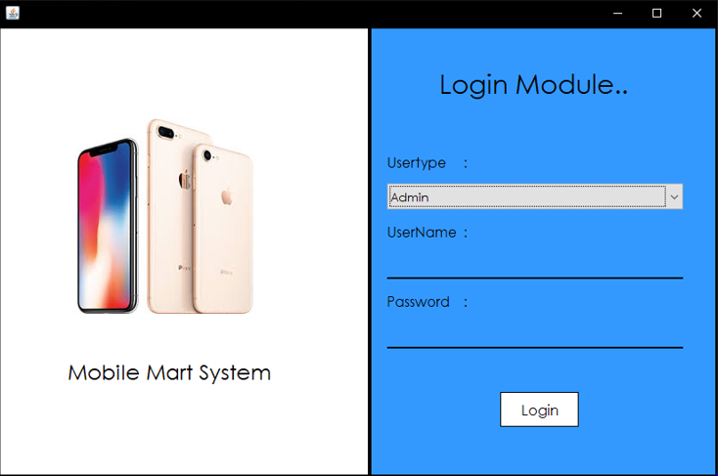

**Admin module**

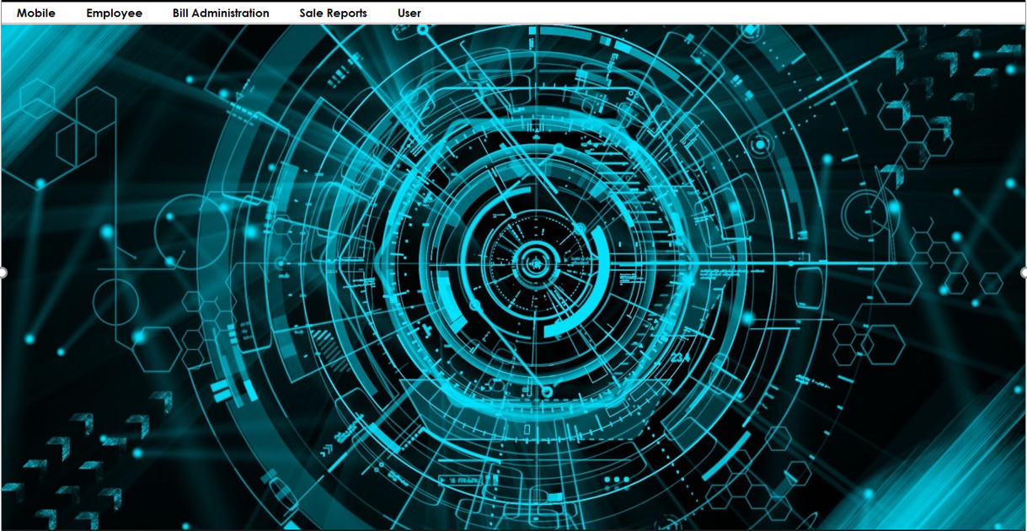

**Add mobile module**

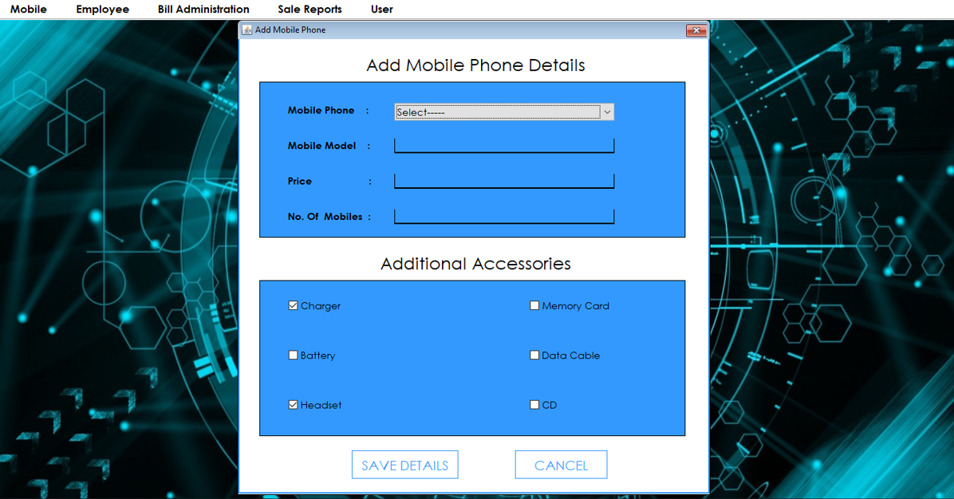

**Search mobile module**

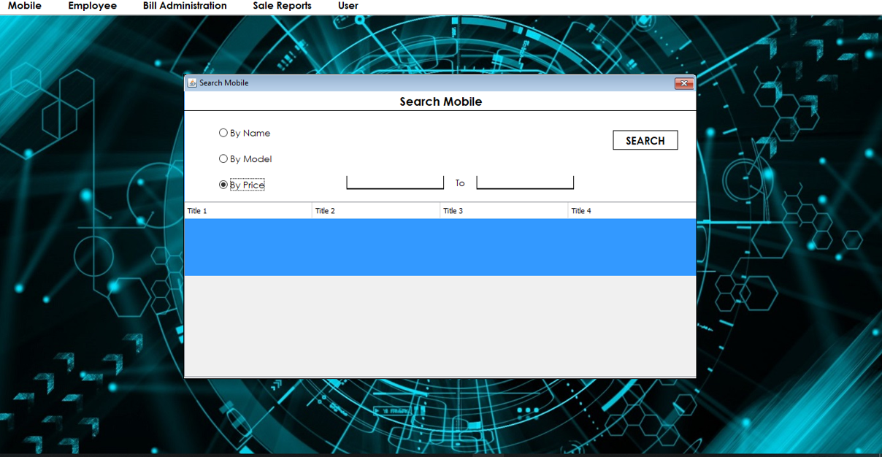

**Update mobile**

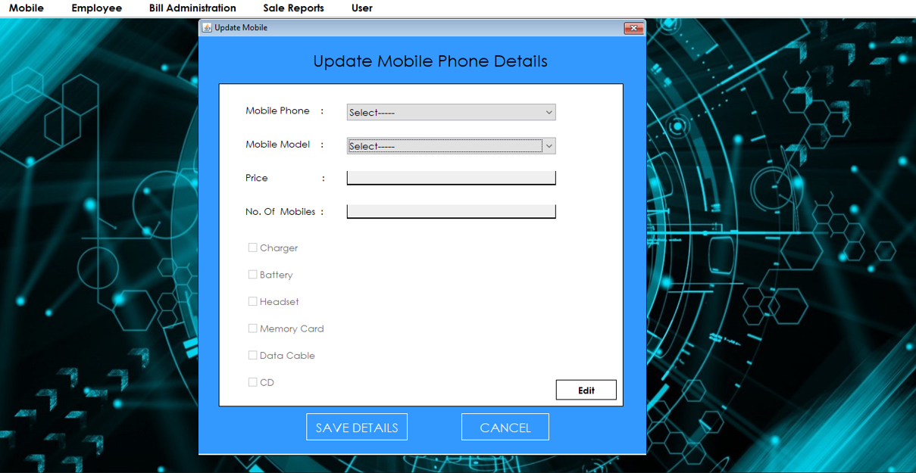

**Delete mobile module**

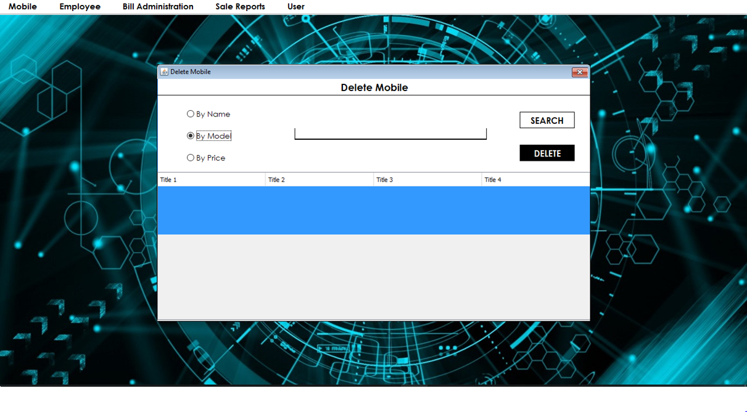

**Add company module**

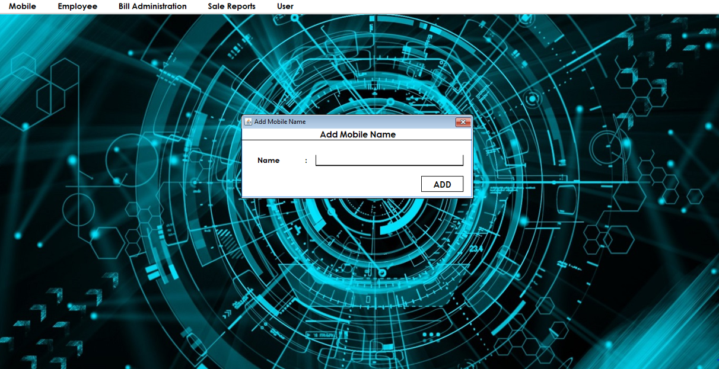

**Add employee module**

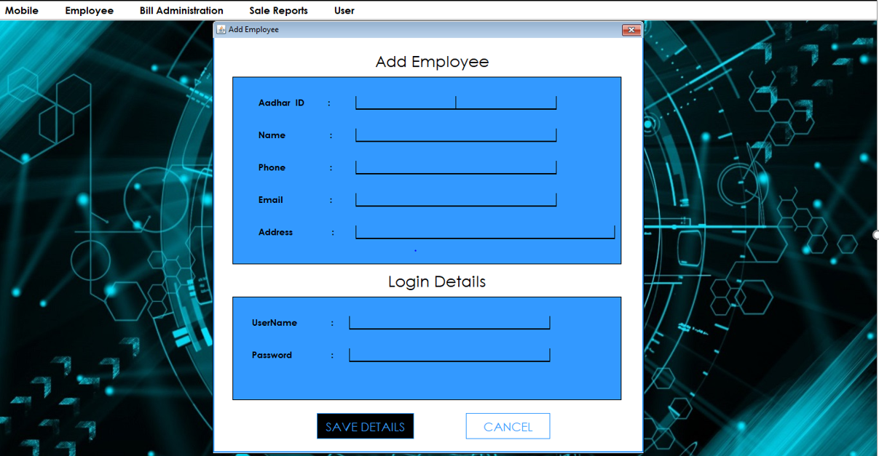

**Search/update/delete employee module**

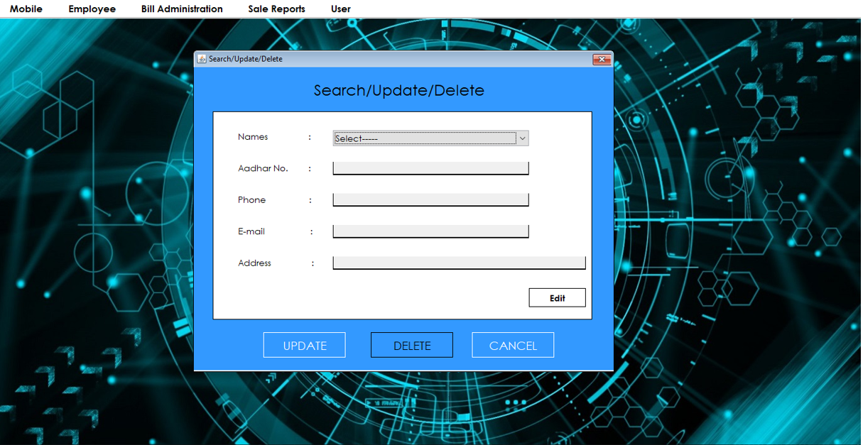

**View list module**

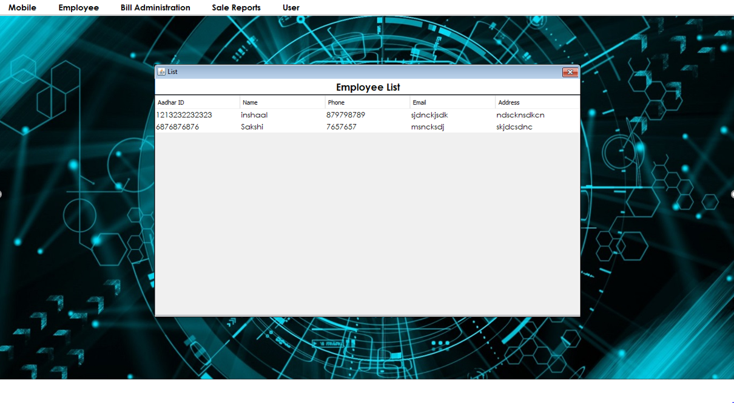

**Generate bill module**

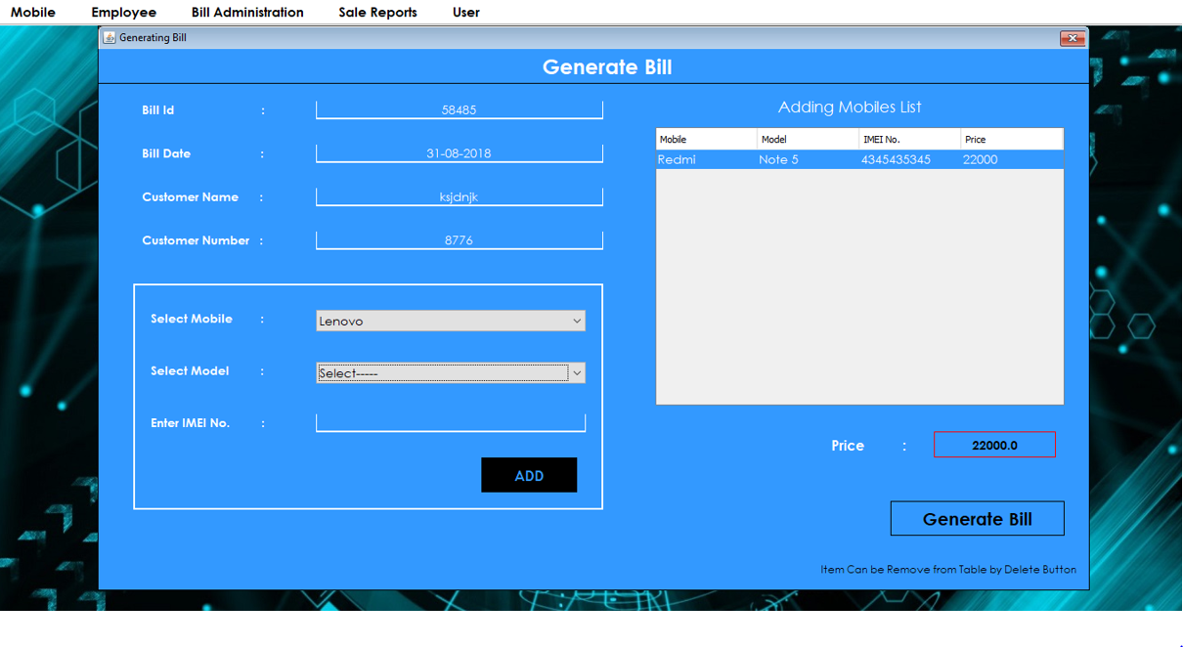

**Bill after generate bill module**

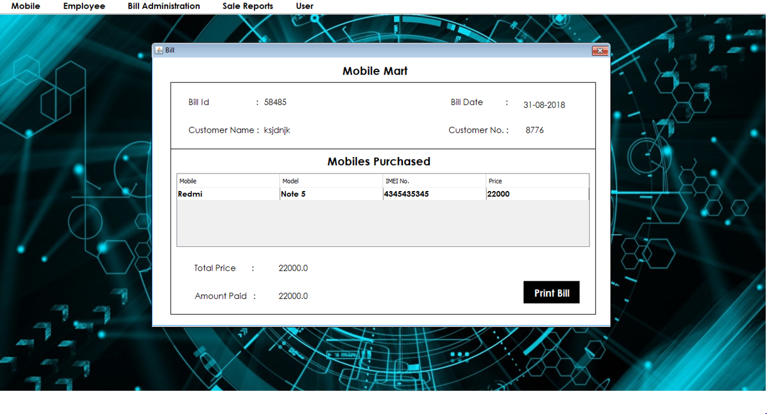

**Search bill module**

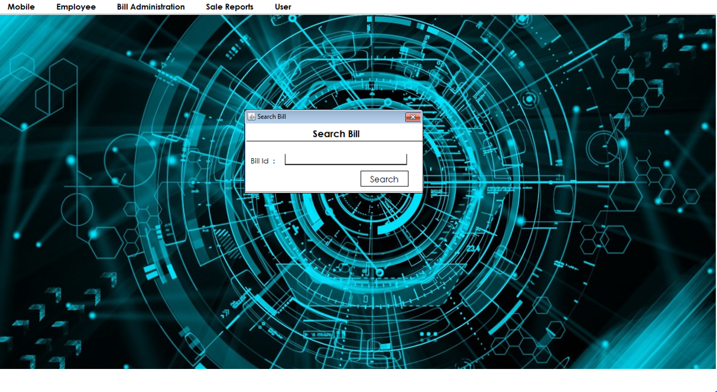

**Sales report(daily) module**

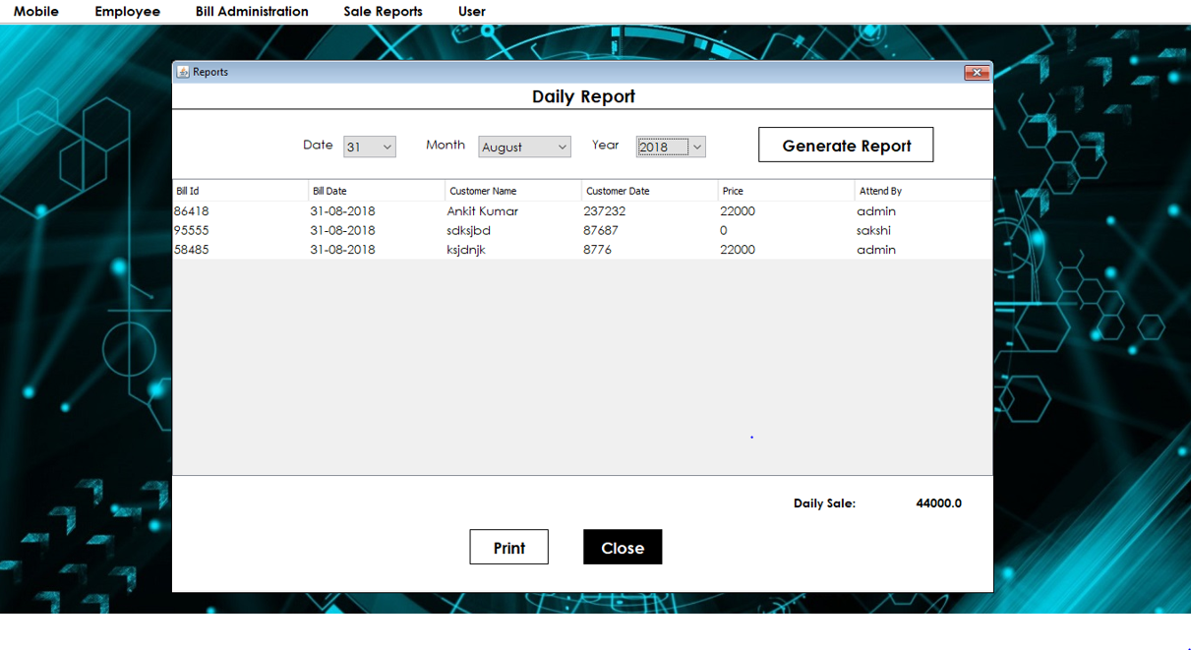

**Sales report(monthly) module**

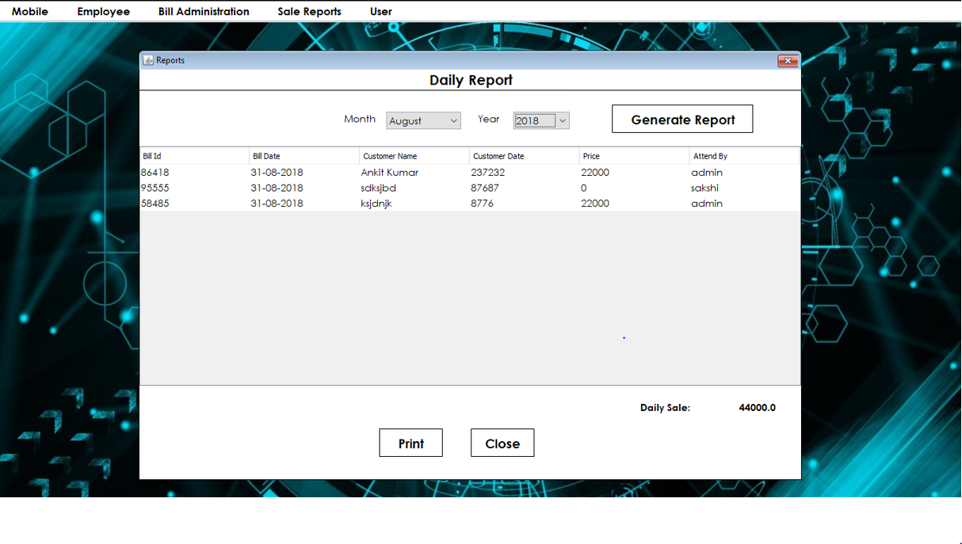

**Sales report (yearly) module**

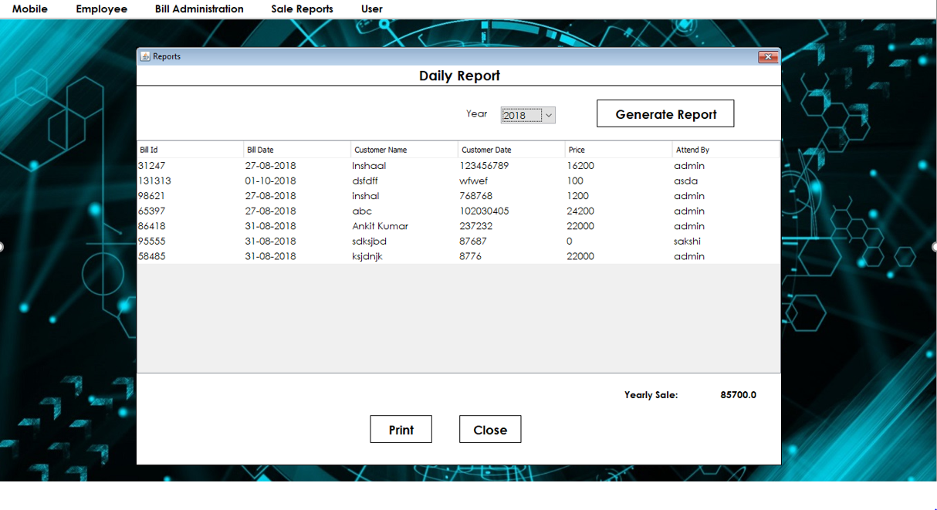

**Change password module**

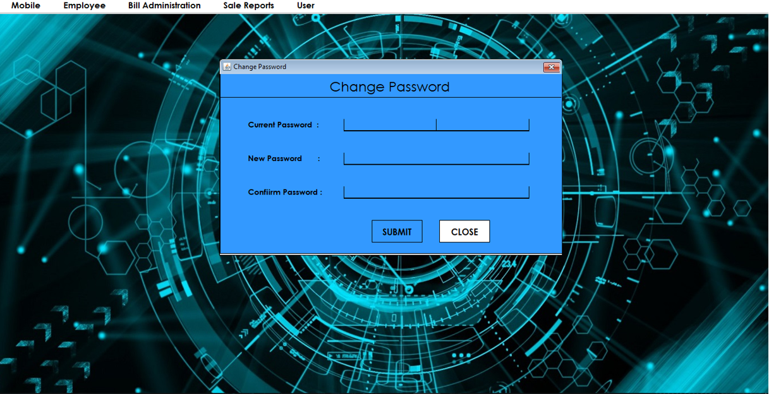

**6.Testing**

This is very important phase. Effective testing will contribute to the delivery of higher quality software products more accurate and reliable result.

During testing, the major activities are focused around the examination and modification of the code. First of all small modules are tested in isolation from the rest of software is known as unit testing. There are problems associated with testing a module in isolation. A module runs without any thing to be called by it and intermediate output obtained during execution of single module.

After unit testing integration testing is performed. In this testing whole modules are integrated. This gives little chance to determine that the interfaces between modules are also correct.

System testing involves the testing of entire system, where as software is a part of system. This is essential to built confidence in the developer before it delivered to customer. Testing has been done in the following areas and manners.

**Functional Testing**

Hypothetical data is used to test the application before implementation. Some temporary Business is created to check the validity and authentication of the user. Various constraints are checked for their working. A demo case will be taken with dummy data for new business.

**Security Testing**

Login and Password is checked and verified for secure login and access.

In case a Administrator forget its Password then application Administrator has right to change the password or allocate new password.

It will be demonstrated that before creating a session, Business cannot make transaction.

Transaction should not be allowed beyond Session date. After Logout Process no protected page should be accessed.

**Performance Testing**

Actual performance of the application can be judged only when system is put with live data. Based on field conditions these testing for fine-tuning can be carried out only at a later date.

* Peak load testing
* Storage Testing
* Performance Testing
* Recovery Testing

**System Testing**

Black box testing method was used for system testing. The black box testing usually demonstrates that software functions are operational; that the input is properly accepted and the output is correctly produced; and that integrity of external information (databases) is maintained.

Why testing is done

Testing is the process of running a system with the intention of finding errors.

Testing enhances the integrity of a system by detecting deviations in design and errors in the system.

Testing aims at detecting error-prone areas. This helps in the prevention of errors in a system.

Testing also add value to the product by confirming to the user requirements.

**Causes of Errors**

The most common causes of errors in a software system are:

Communication gap between the developer and the business decision maker: A communication gap between the developer and the business decision maker is normally due to subtle differences between them. The differences can be classified into five broad areas: Thought process, Background and Experience, Interest, Priorities, Language.

Time provided to a developer to complete the project: A common source of errors in projects comes from time constraints in delivering a product. To keep to the schedule, features can be cut. To keep the features, the schedule can be slipped. Failing to adjust the feature set or schedule when problems are discovered can lead to rushed work and flawed systems.

Over Commitment by the developer: High enthusiasm can lead to over commitment by the developer. In these situations, developers are usually unable to adhere to deadlines or quality due to lack of resources or required skills on

the team.

Insufficient testing and quality control: Insufficient testing is also a major source of breakdown of e-commerce systems during operations, as testing must be done during all phases of development.

Inadequate requirements gathering: A short time to market results in developers starting work on the Web site development without truly understanding the business and technical requirements. Also, developers may create client-side scripts using language that may not work on some client browsers.

Keeping pace with the fast changing Technology: New technologies are constantly introduced. There may not be adequate time to develop expertise in the new technologies. This is a problem for two reasons. First, the technology may not be properly implemented. Second, the technology may not integrate well with the existing environment.

**Testing Principles**

To discover as yet undiscovered errors.

All tests should be traceable to customer’s requirement.

Tests should be planned long before the testing actually begins.

Testing should begin “in the small” & progress towards “testing in the large”.

Exhaustive Testing is not possible.

To be most effective training should be conducted by an Independent Third Party

Testing Objectives

Testing is a process of executing a program with the intent of finding errors.

A good test case is one that has a high probability of finding an as yet undiscovered error.

A successful test is one that uncovers an as yet undiscovered error.

**Kinds of Testing**

**Black Box Testing-** Not based on any knowledge of internal designs or code. Tests are based on requirements and functionality.

**White Box Testing-** Based on the knowledge of the internal logic of an application’s code. Tests are based on coverage of code statements, branches, paths and statements.

**Unit Testing-** The most ‘micro’ scale of testing; to test particular functions and code modules. Typically done by the programmer and not by the testers, as it requires detailed knowledge of the internal program design and code. Not always easily done unless the application has a well-designed architecture with tight code; may require developing test driver modules or test harnesses.

**Integration Testing-** Testing of combined parts of an application to determine if they function together correctly. The ‘parts’ can be code modules, individual applications, client and server applications on a network, etc. This type of testing is especially relevant to client/ server and distributed systems.

**Functional Testing-** Black-box type testing geared to functional requirements of an application; testers should do this type of testing. This doesn’t mean that the programmers shouldn’t check that their code works before releasing it.

**Regression Testing-** Re-testing after fixes or modifications of the software or its environment. It is difficult to determine how much re testing is needed, especially near the end of the development cycle. Automated testing tools can be especially useful for this type of testing.

**Acceptance Testing-** Final testing based on the specifications of the end user or customer or based on use by end-users/ customers over some limited period of time.

**User Acceptance Testing-** Determining if software is satisfactory to an end user customer.

**Testing Technique Used:**

We will continuously test our project to insure that it is fully functional. In order to perform testing test cases are designed with the intent of finding the errors in the project and help in removing those errors. Testing begins at the module level and is conducted systematically. It is generally conducted by independent test groups or third party.

Testing is done in our project Boutique Management System with help of black box testing that exercise all the functional requirement of the project test cases are designed using this approaches by providing set of input conditions to get the expected output.

**Test Cases Designed**

**TEST CASES FOR CLIENT**

|  |  |  |  |
| --- | --- | --- | --- |
| **TEST CASE ID** | **INPUT** | **EXPECTED OUTPUT** | **ACTUAL OUTPUT** |
| 1 | Password and key combination | Start | Operation started |
| 2 | No Input | Alert Message | Select a valid configuration setting |

**TEST CASES FOR SERVER**

|  |  |  |  |
| --- | --- | --- | --- |
| **TEST CASE ID** | **INPUT** | **EXPECTED OUTPUT** | **ACTUAL OUTPUT** |
| 1 | 127.0.0.1 | Connection establish | Client Connected |
| 2 | Get Status | Alert Box | If no client selected “alert box” is displayed |
| 3 | Choose Path | Transfer files to valid path | Files transferred |

**7.Implementation**

**Implementation of Security**

Security is an important issue for modern IT system. System administrator and security administrator are responsible for safeguard’s organization data and computing infrastructure.

**Password Encryption**

Whatever security measures taken, in any case if anyone with destructive or malicious mind gets access to the database he can temper the critical data. To restrict it we’ve used encrypting algorithm facilitated to us by Microsoft ASP.Net .

Two algorithms’ are there-

SHA1- It takes the password and encrypt it in a string of 40 characters.

MD5- It takes the password and encrypt it in a string of 32 characters.

The beauty of these Algorithms are that whatever be the length of password the length of converted string remains same. However a question arise here that if this thing is that good then why didn’t we used it for storing each and every data????

The answer lies in the fact that not all data are needed to be encrypted as long as we keep the critical data(like password encrypted and safe). It will only increase the load on server and network with no additional advantage. So we’ve not used this encryption Algorithm on all data blindly.

We have implemented different approach related to security issue for our project “Mobile Mart System”.

**Authorization**

Only admin has the authorized to access all the information regarding customers and mobiles.

**Information Integrity**

Only admin has right in the modification of the information. There is no possibility by the end user or unauthorized user of hacking the information.

**Detection**

Admin will have a bank up of the project. Also there is a complex and alphanumeric password for admin and employee. There is a option for changing the password by the admin.

**8.Future Scope**

**Future Scope of the Project**

In a nutshell, it can be summarized that the future scope of the project circles around maintaining information regarding:

We can add printer in future.

We can give more advance software for Mobile Mart System including more facilities

We will host the platform on servers to make it accessible worldwide

Integrate multiple load balancers to distribute the loads of the system

Create the master and slave database structure to reduce the overload of the database queries

Implement the backup mechanism for taking backup of codebase and database on regular basis on different servers

The above mentioned points are the enhancements which can be done to increase the applicability and usage of this project. Here we can maintain the records of Mobiles and Customers.

We have left all the options open so that if there is any other future requirement in the system by the user for the enhancement of the system then it is possible to implement them. In the last we would like to thanks all the persons involved in the development of the system directly or indirectly. We hope that the project will serve its purpose for which it is develop there by underlining success of process.

**9.Limitations**

## Limitation of Project on Mobile Mart System

Although I have put my best efforts to make the software flexible, easy to operate but limitations cannot be ruled out even by me. Though the software presents a broad range of options to its users some intricate options could not be covered into it; partly because of logistic and partly due to lack of sophistication. Paucity of time was also major constraint, thus it was not possible to make the software fullproof and dynamic. Lack of time also compelled me to ignore some part such as storing old result of the candidate etc.

Considerable efforts have made the software easy to operate even for the people not related to the field of computers but it is acknowledged that a layman may find it a bit problematic at the first instance. The user is provided help at each step for his convenience in working with the software.

**List of limitations which are available in the Mobile Mart System**

* Excel export has not been developed for Boutique, Designer due to some criticality.
* The transactions are executed in off-line mode, hence on-line data for Customer, Designs capture and modification is not possible.
* Off-line reports of Mobile and Customers cannot be generated due to batch mode execution.

**10.Conclusion**

**Conclusion of the Mobile Mart System**

Our project is only a humble venture to satisfy the needs to manage their project work. Several user friendly coding have also adopted. This package shall prove to be a powerful package in satisfying all the requirements of the customers. The objective of software planning is to provide a frame work that enables the manger to make reasonable estimates made within a limited time frame at the beginning of the software project and should be updated regularly as the project progresses.

**At the end it is concluded that we have made effort on following points…**

* A description of the background and context of the project and its relation to work already done in the area.
* Made statement of the aims and objectives of the project.
* The description of Purpose, Scope, and applicability.
* We define the problem on which we are working in the project.
* We describe the requirement Specifications of the system and the actions that can be done on these things.
* We understand the problem domain and produce a model of the system, which describes operations that can be performed on the system.
* We included features and operations in detail, including screen layouts.
* We designed user interface and security issues related to system.
* Finally the system is implemented and tested according to test cases.

**11.References**

Reference Books

Herbert Schildt, JAVA2 COMPLETE REFERENCE, 5TH edition, Pragati publication, April 2004

Pankaj Sharma, INTRODUCTION TO WEB TECHNOLOGY, 2nd edition S.K.

Kataria & Sons publication, April 2007

Shrika Jain, INFARMATION SYSTEM, 3rd edition, Pragati publication, April

2004

Roger S. Pressman, SOFTWARE ENGINEERING, 3rd edition by McGraw Hill

International, April 2002

Reference websites

* + [www.stardeveloper.con](http://www.stardeveloper.con)
  + [www.javaskyline.com](http://www.javaskyline.com)
  + [www.apl.jhu.edu](http://www.apl.jhu.edu)
  + [www.javaworld.com](http://www.javaworld.com)